Lab 3

Jiahui Wu

ID: 2670210

Description: designing and building a data mining project with cube and OLAP. Building a business analytic data mining model using Microsoft BI data mining tool and data warehouse and OLAP cubes.

Part1. Cube designing

1.1 Create new project using business intelligence template, choose analysis services multidimensional and data mining project.

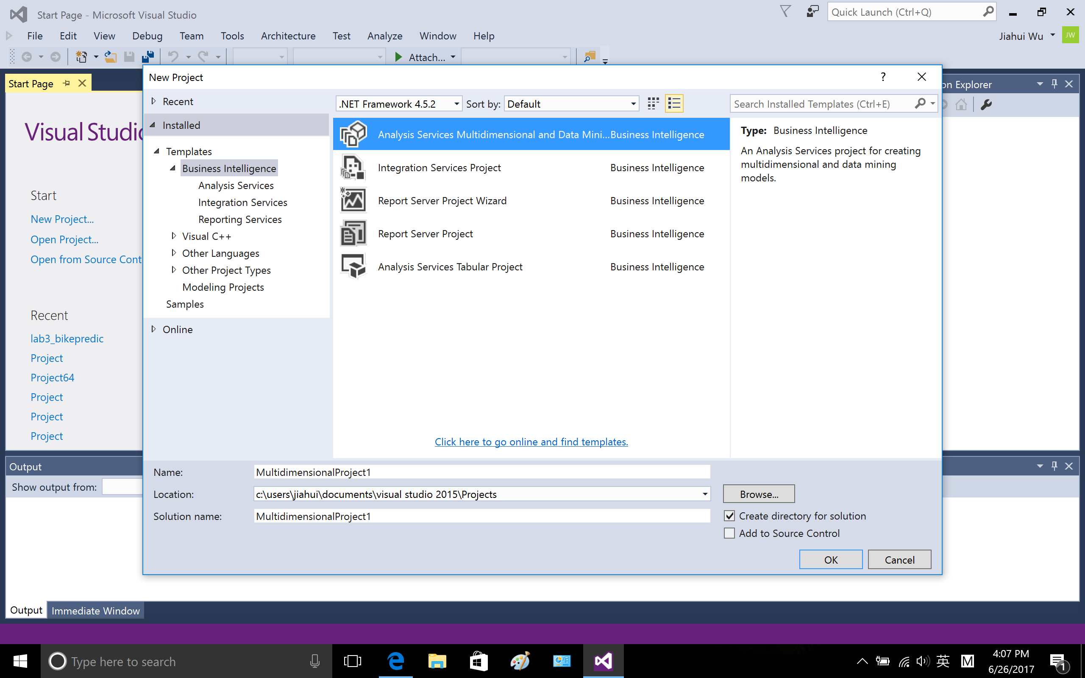

1.2 data sources

Right click the data source and create connection to my local database sql server, the database I used is AdventureWorksDW2014.

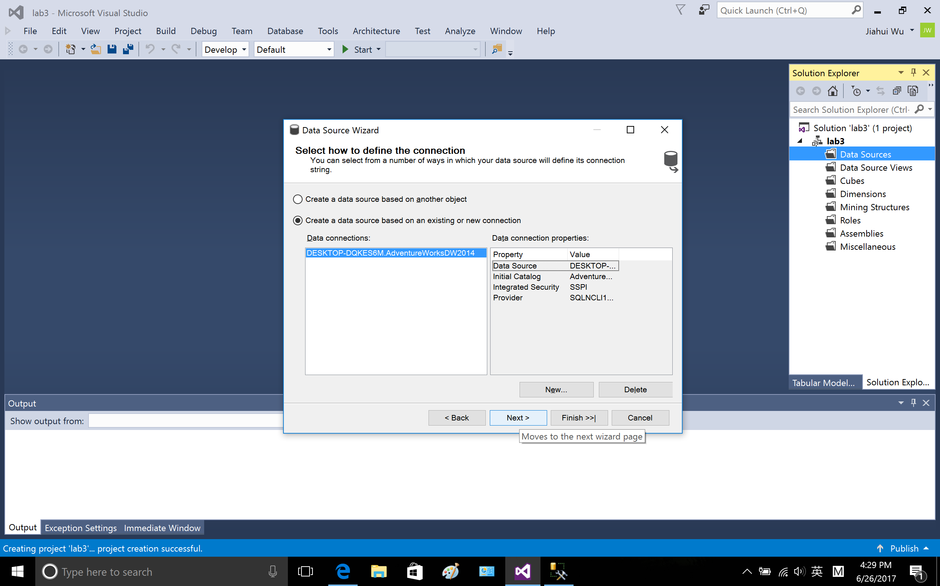

Choose inherit

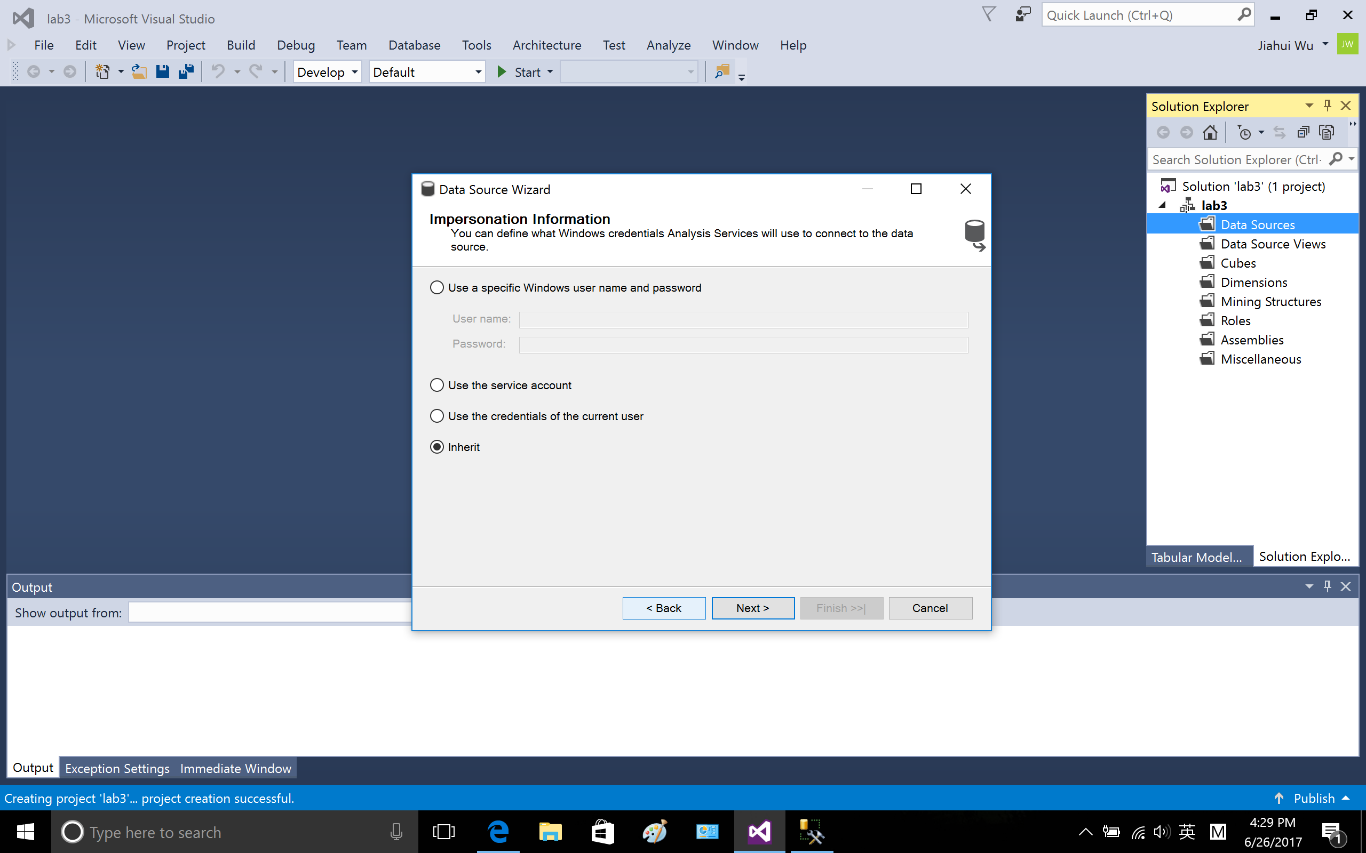

Confirm the database, finish

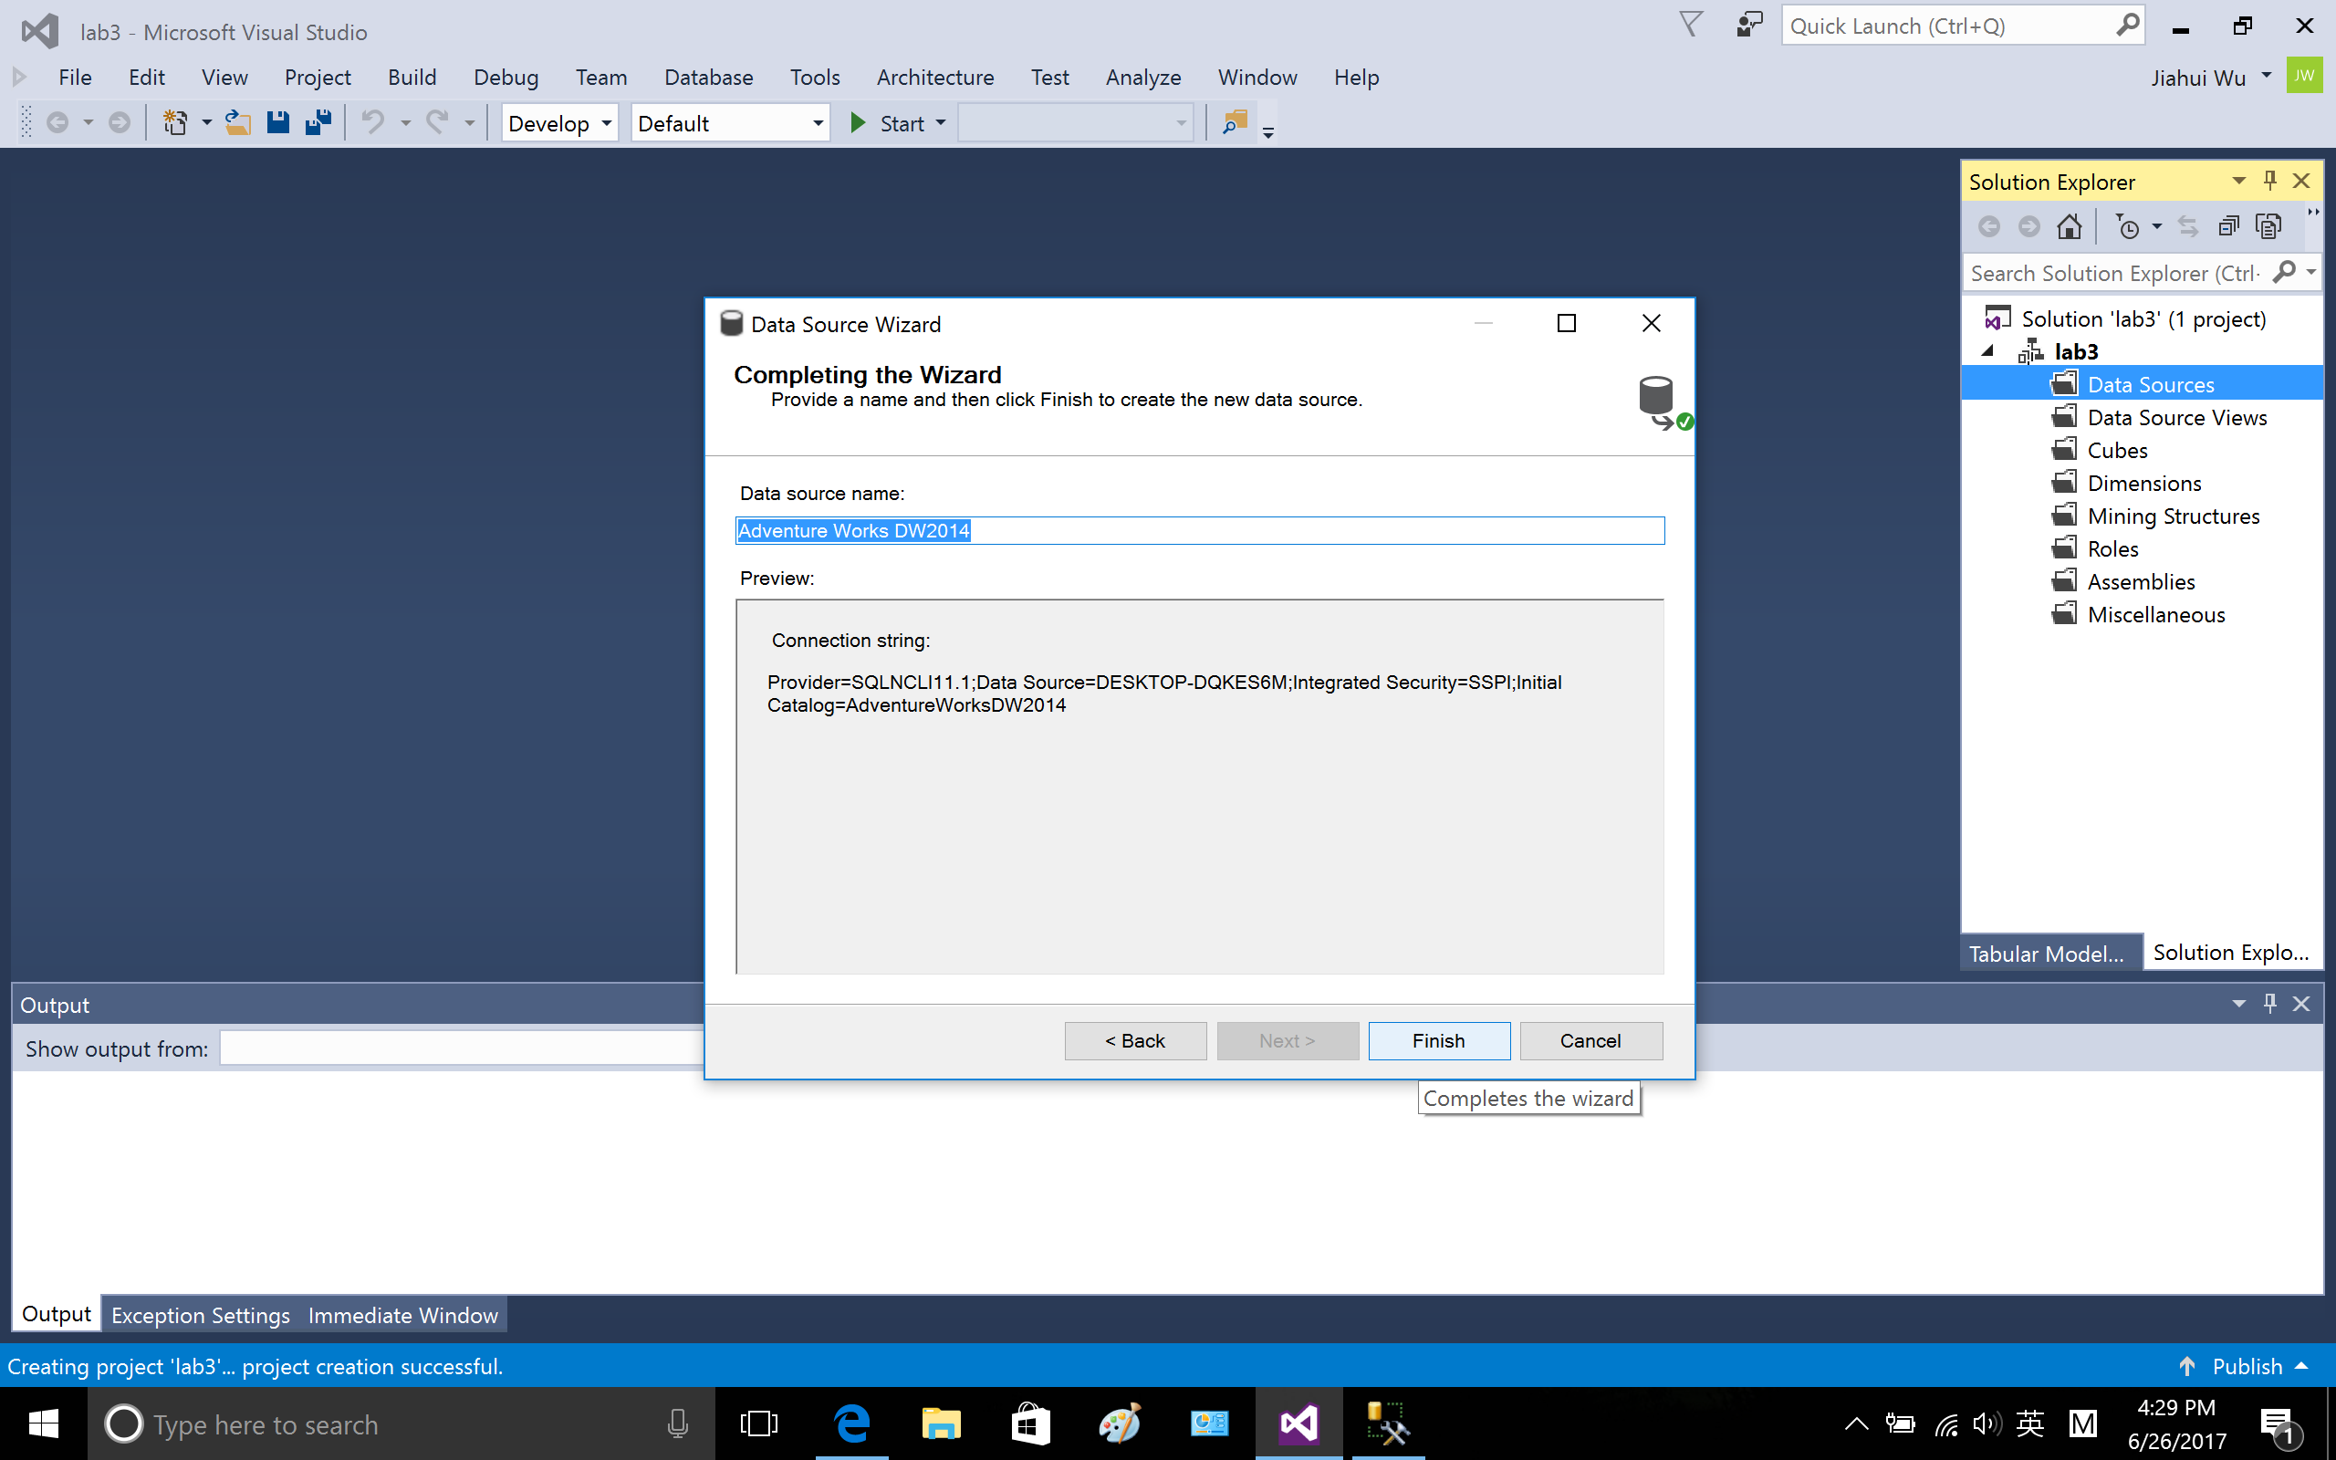

1.3 data source views, right click to create new data source view.

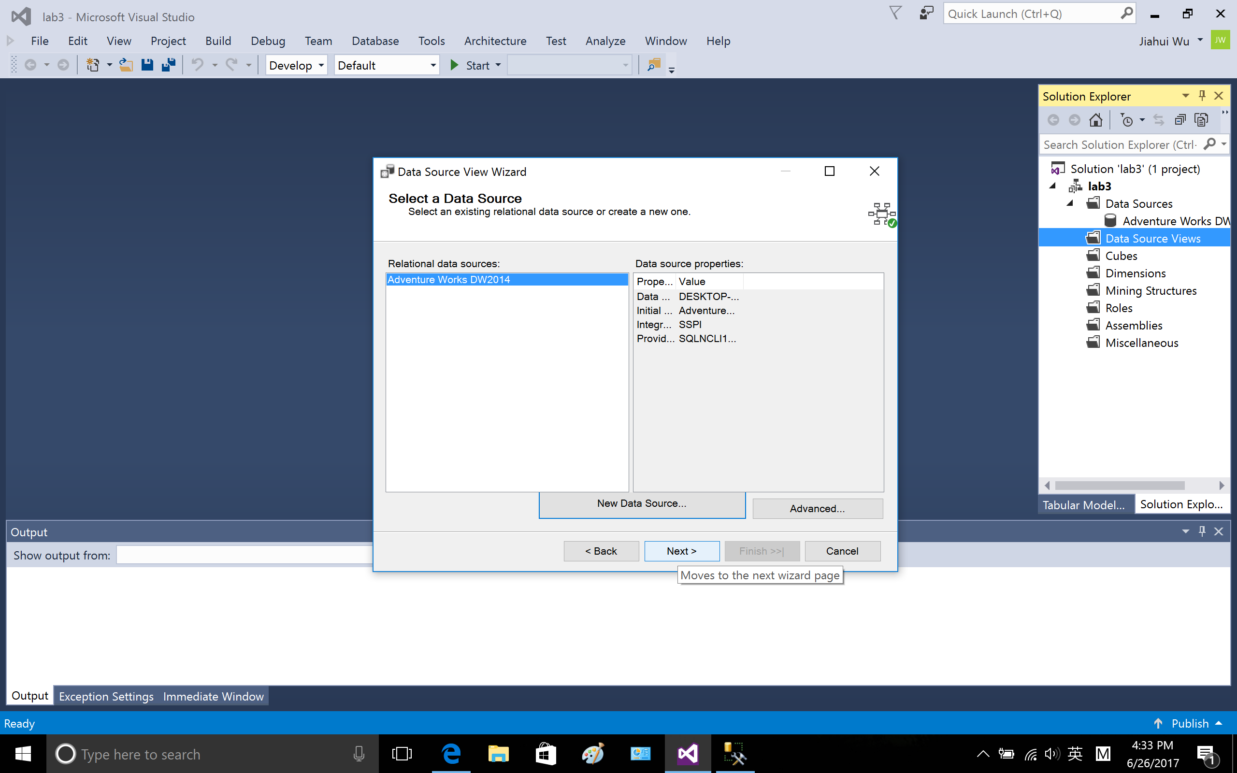

Include the following tables: DimCustomer, DimGeography, DimProduct, DimDate and FactInternetSales

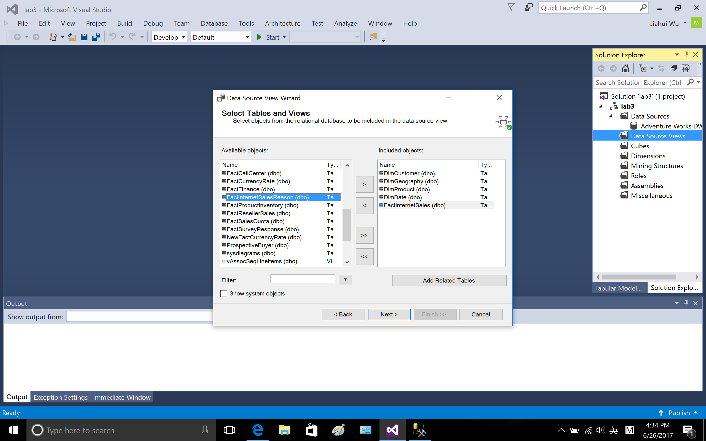

finish

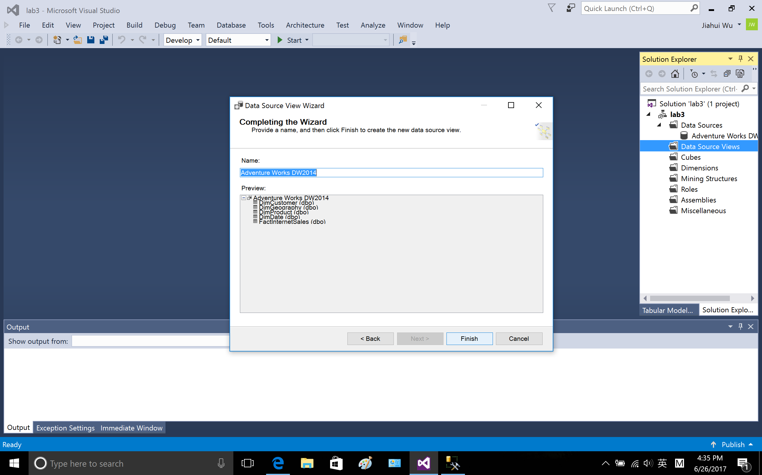

The star schema of the selected data.

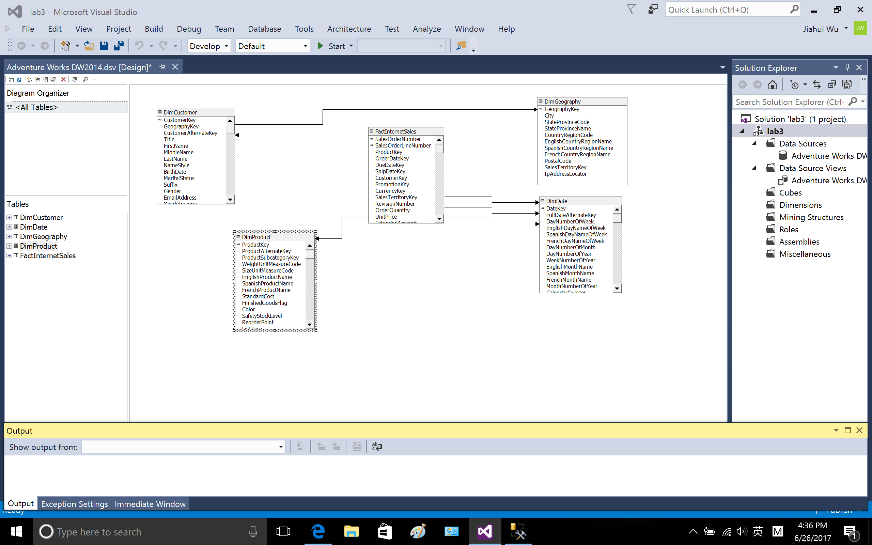

1.4 create dimensions of DimDate (try to learn create dimensions, other dimensions are not created in this way)

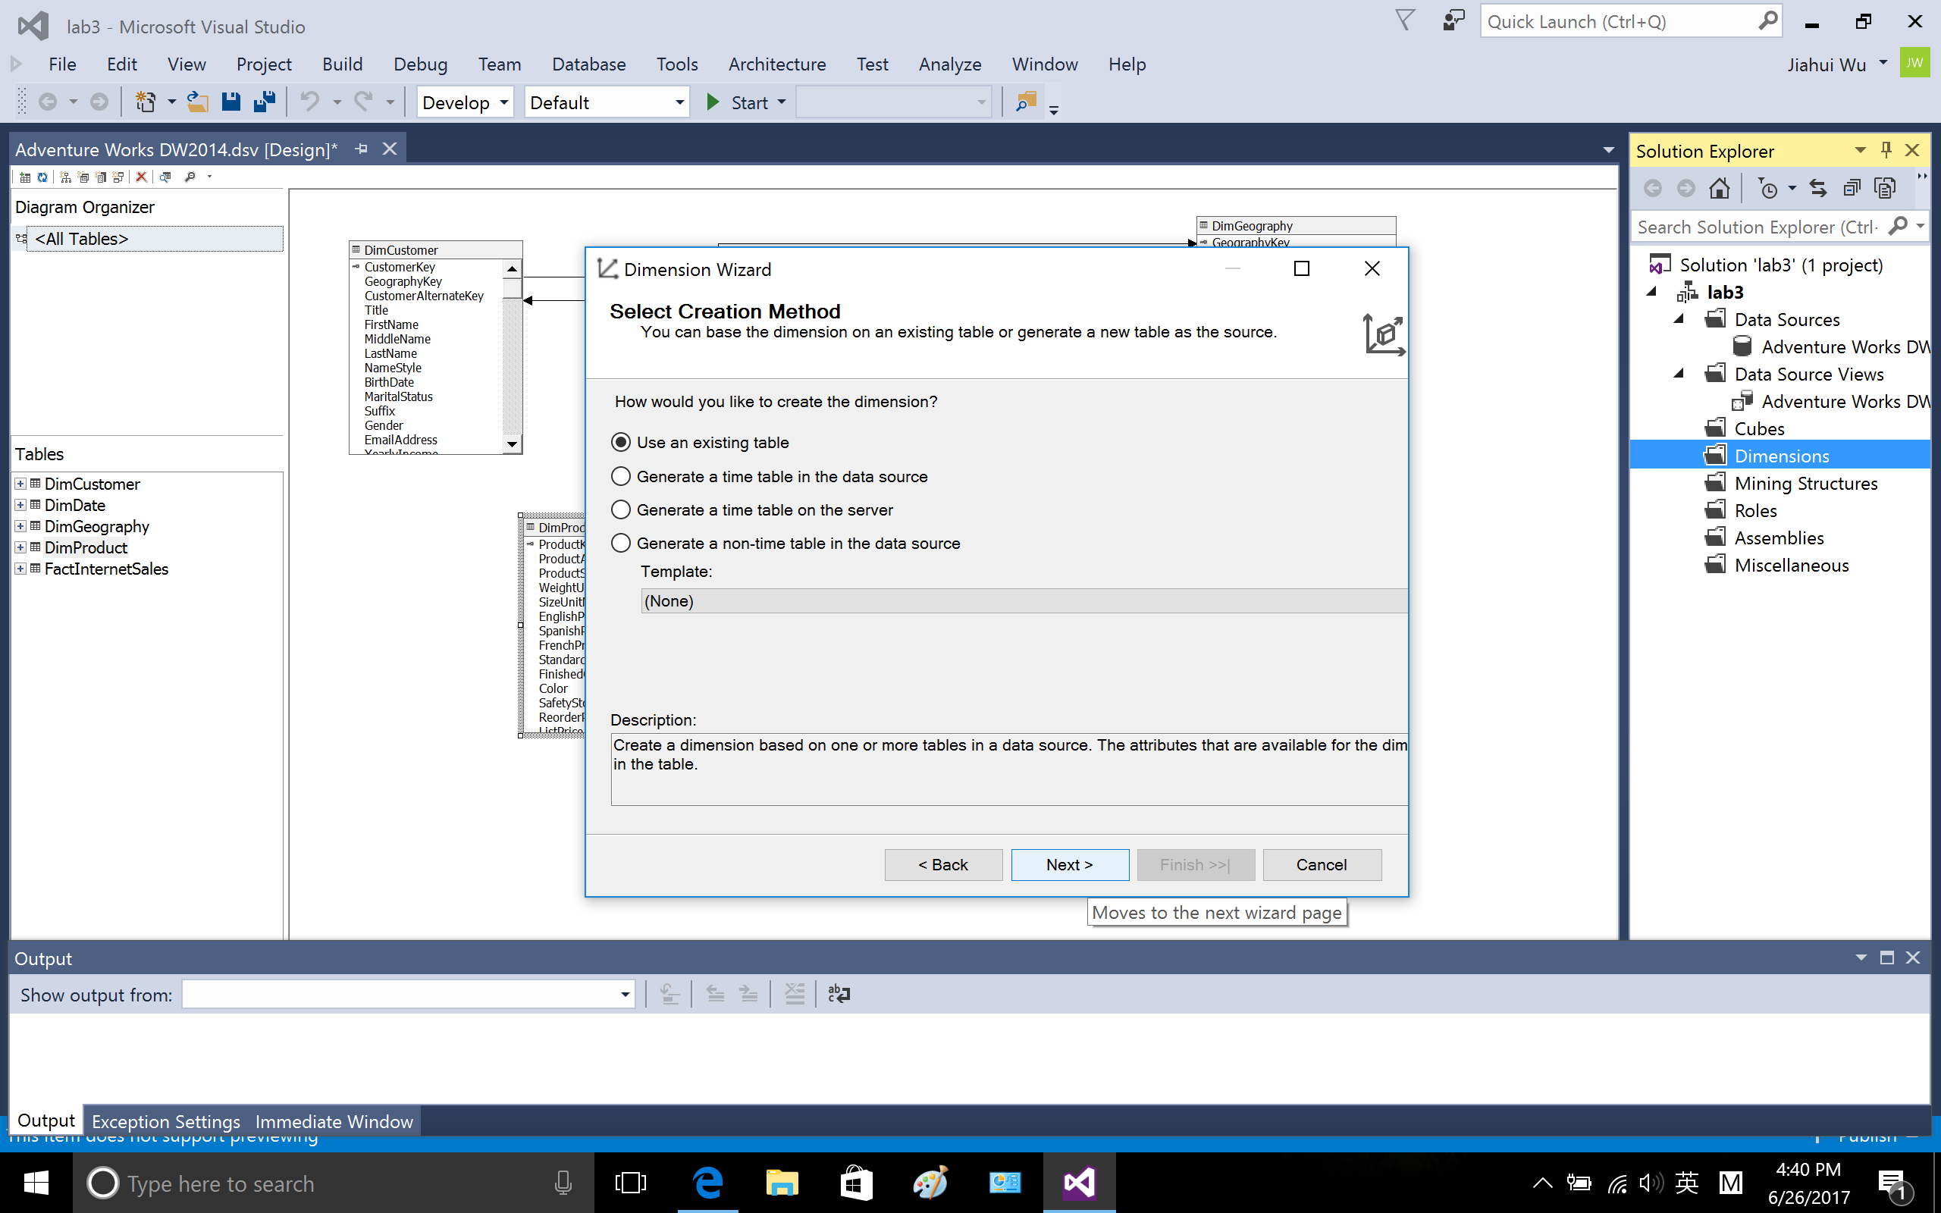

Choose FactInternetSale as measure group tables.

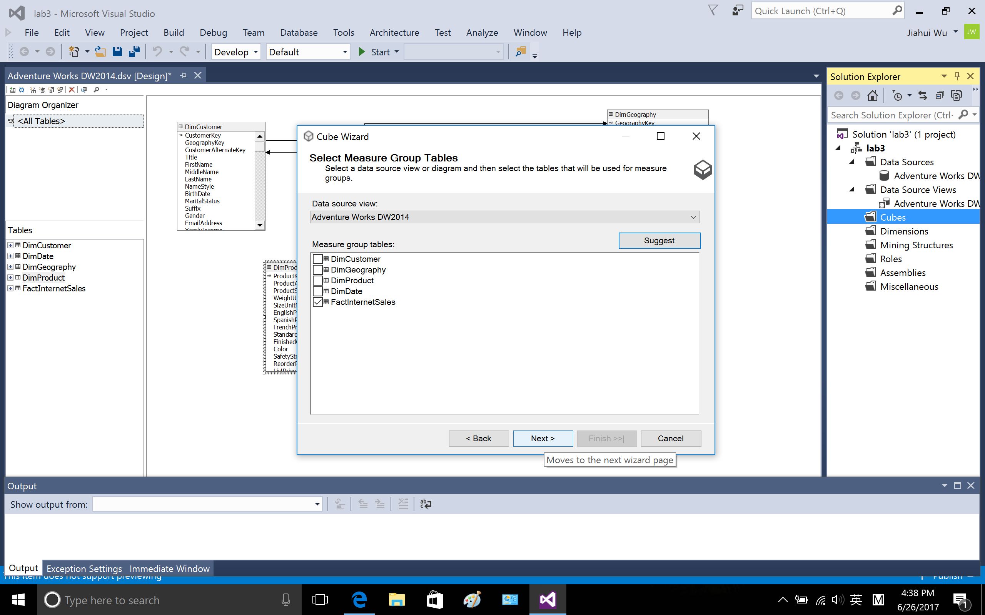

In the main table, choose DimDate

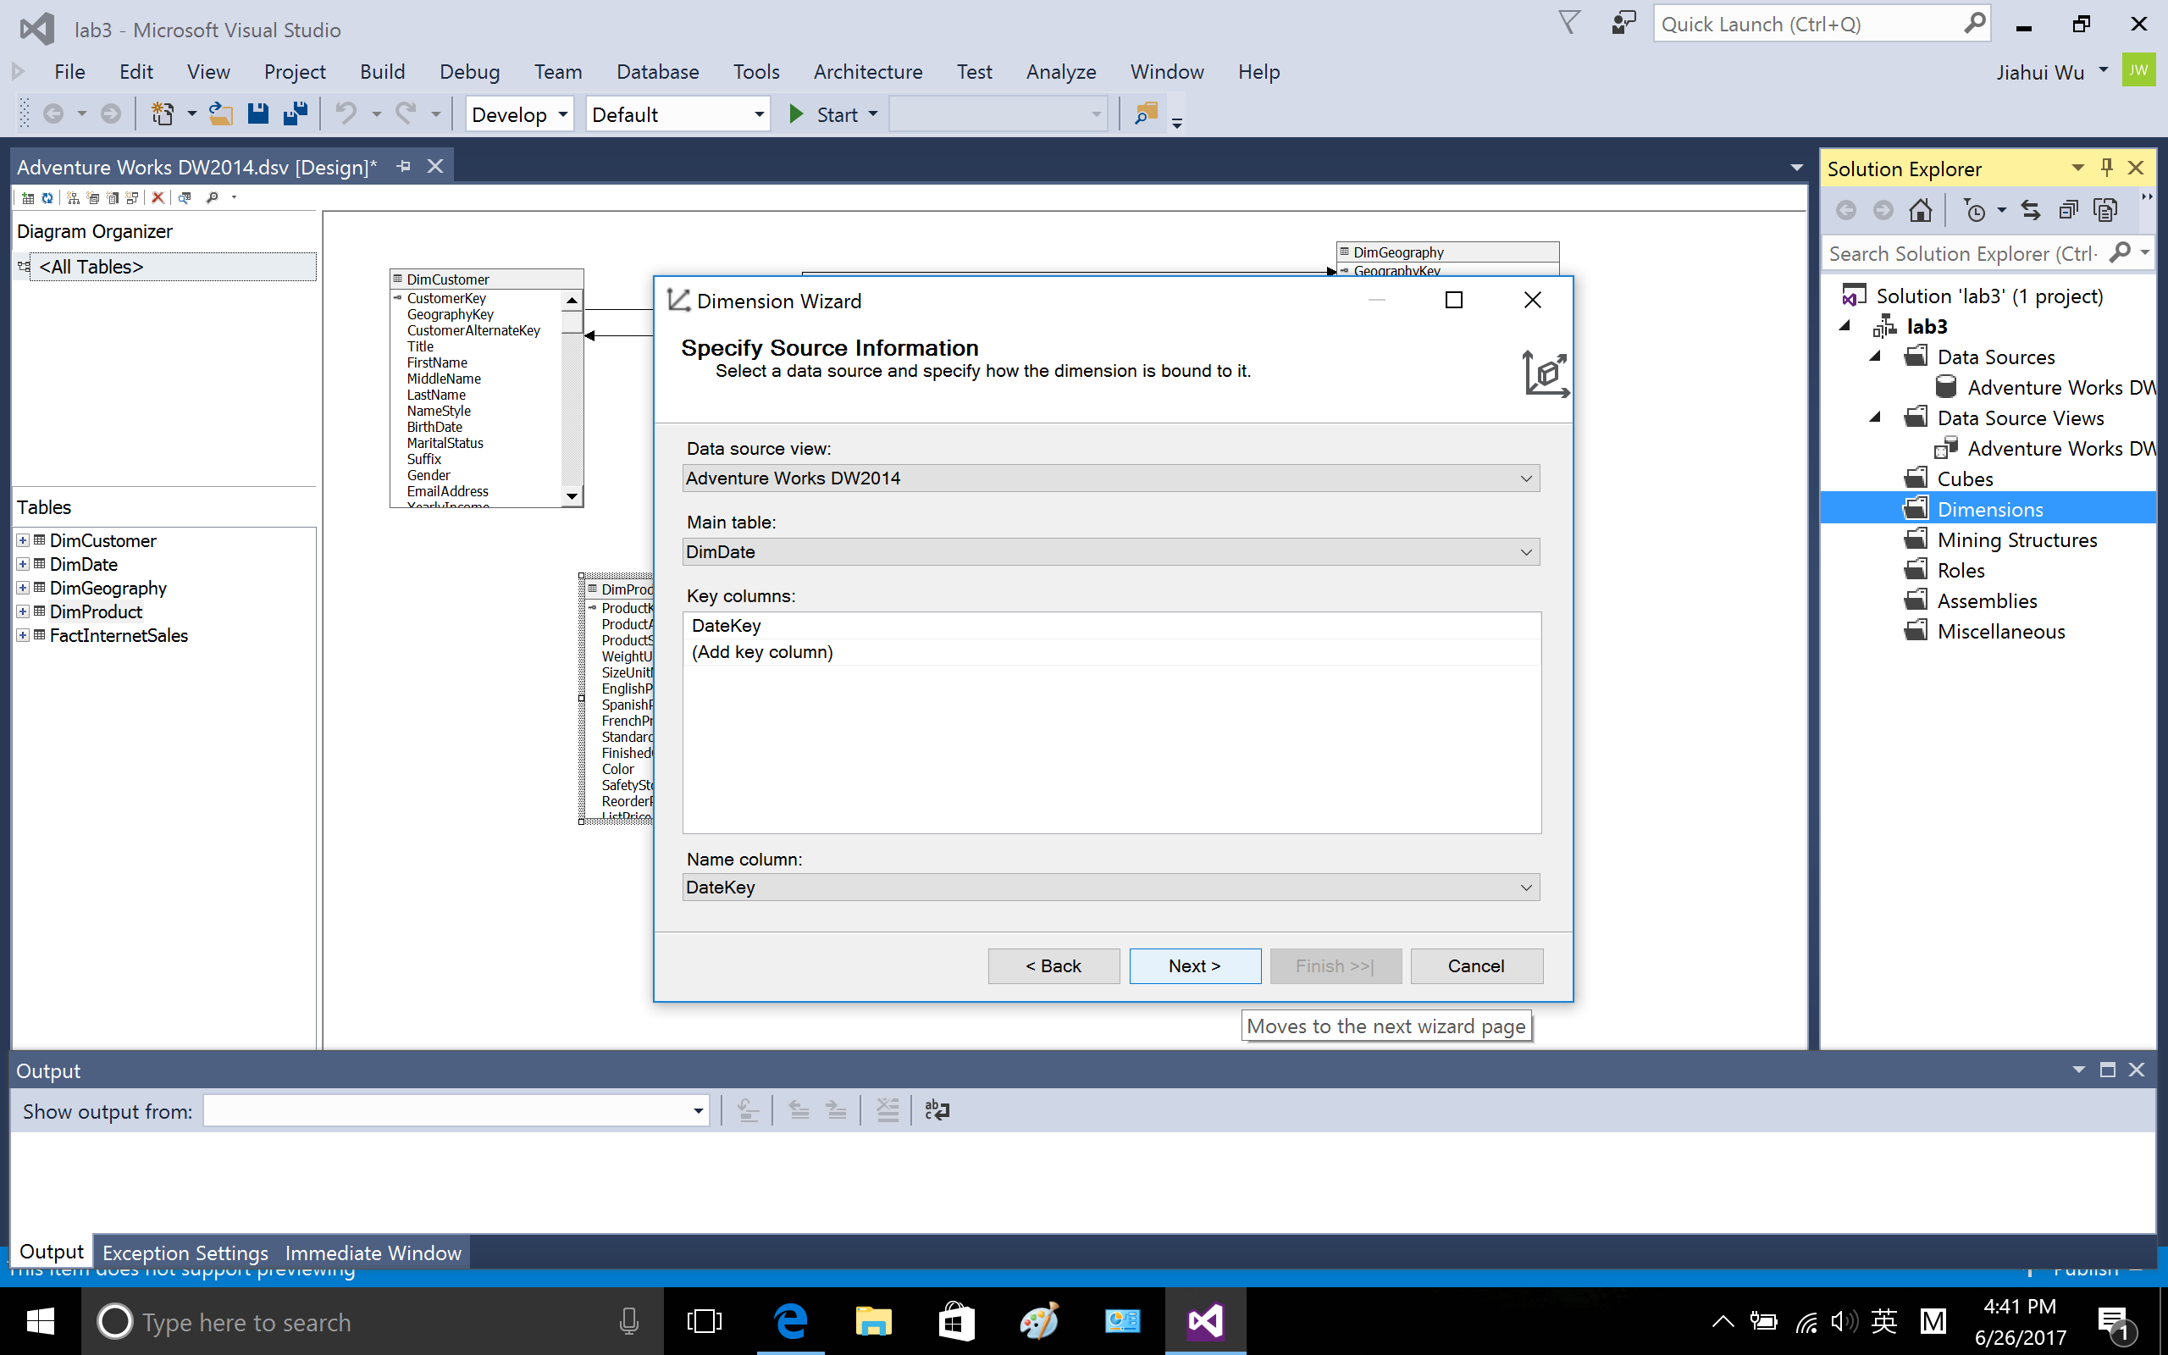

Select the following attribute.

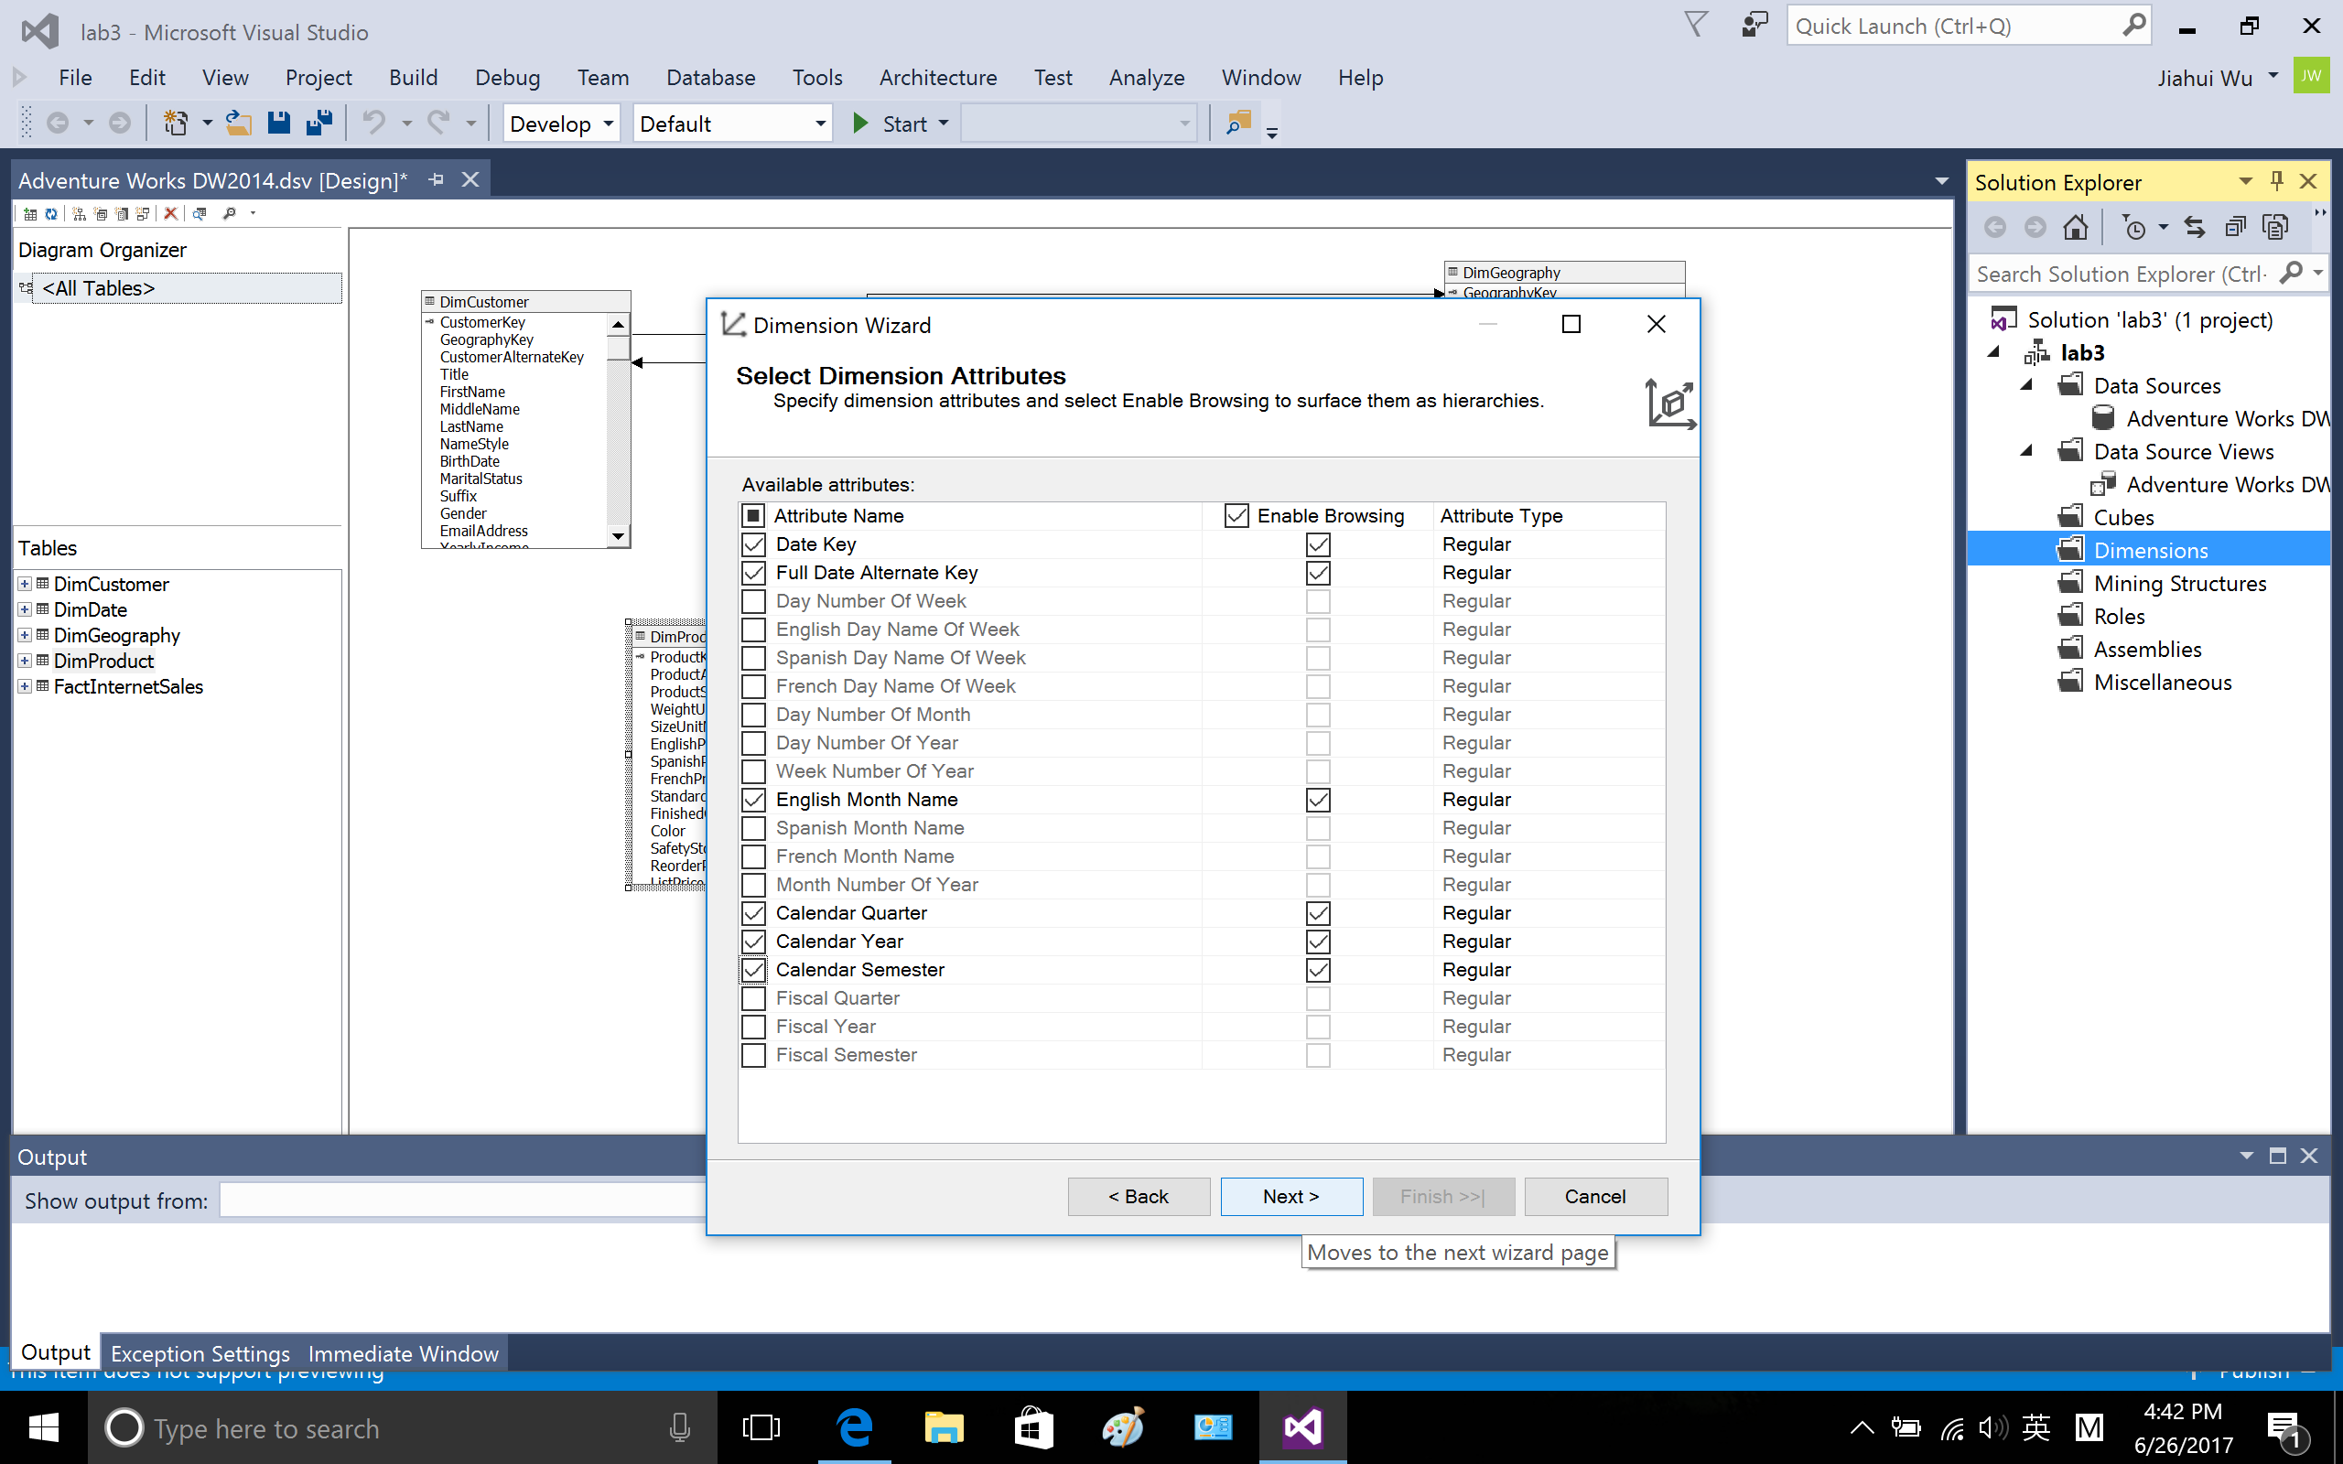

finish

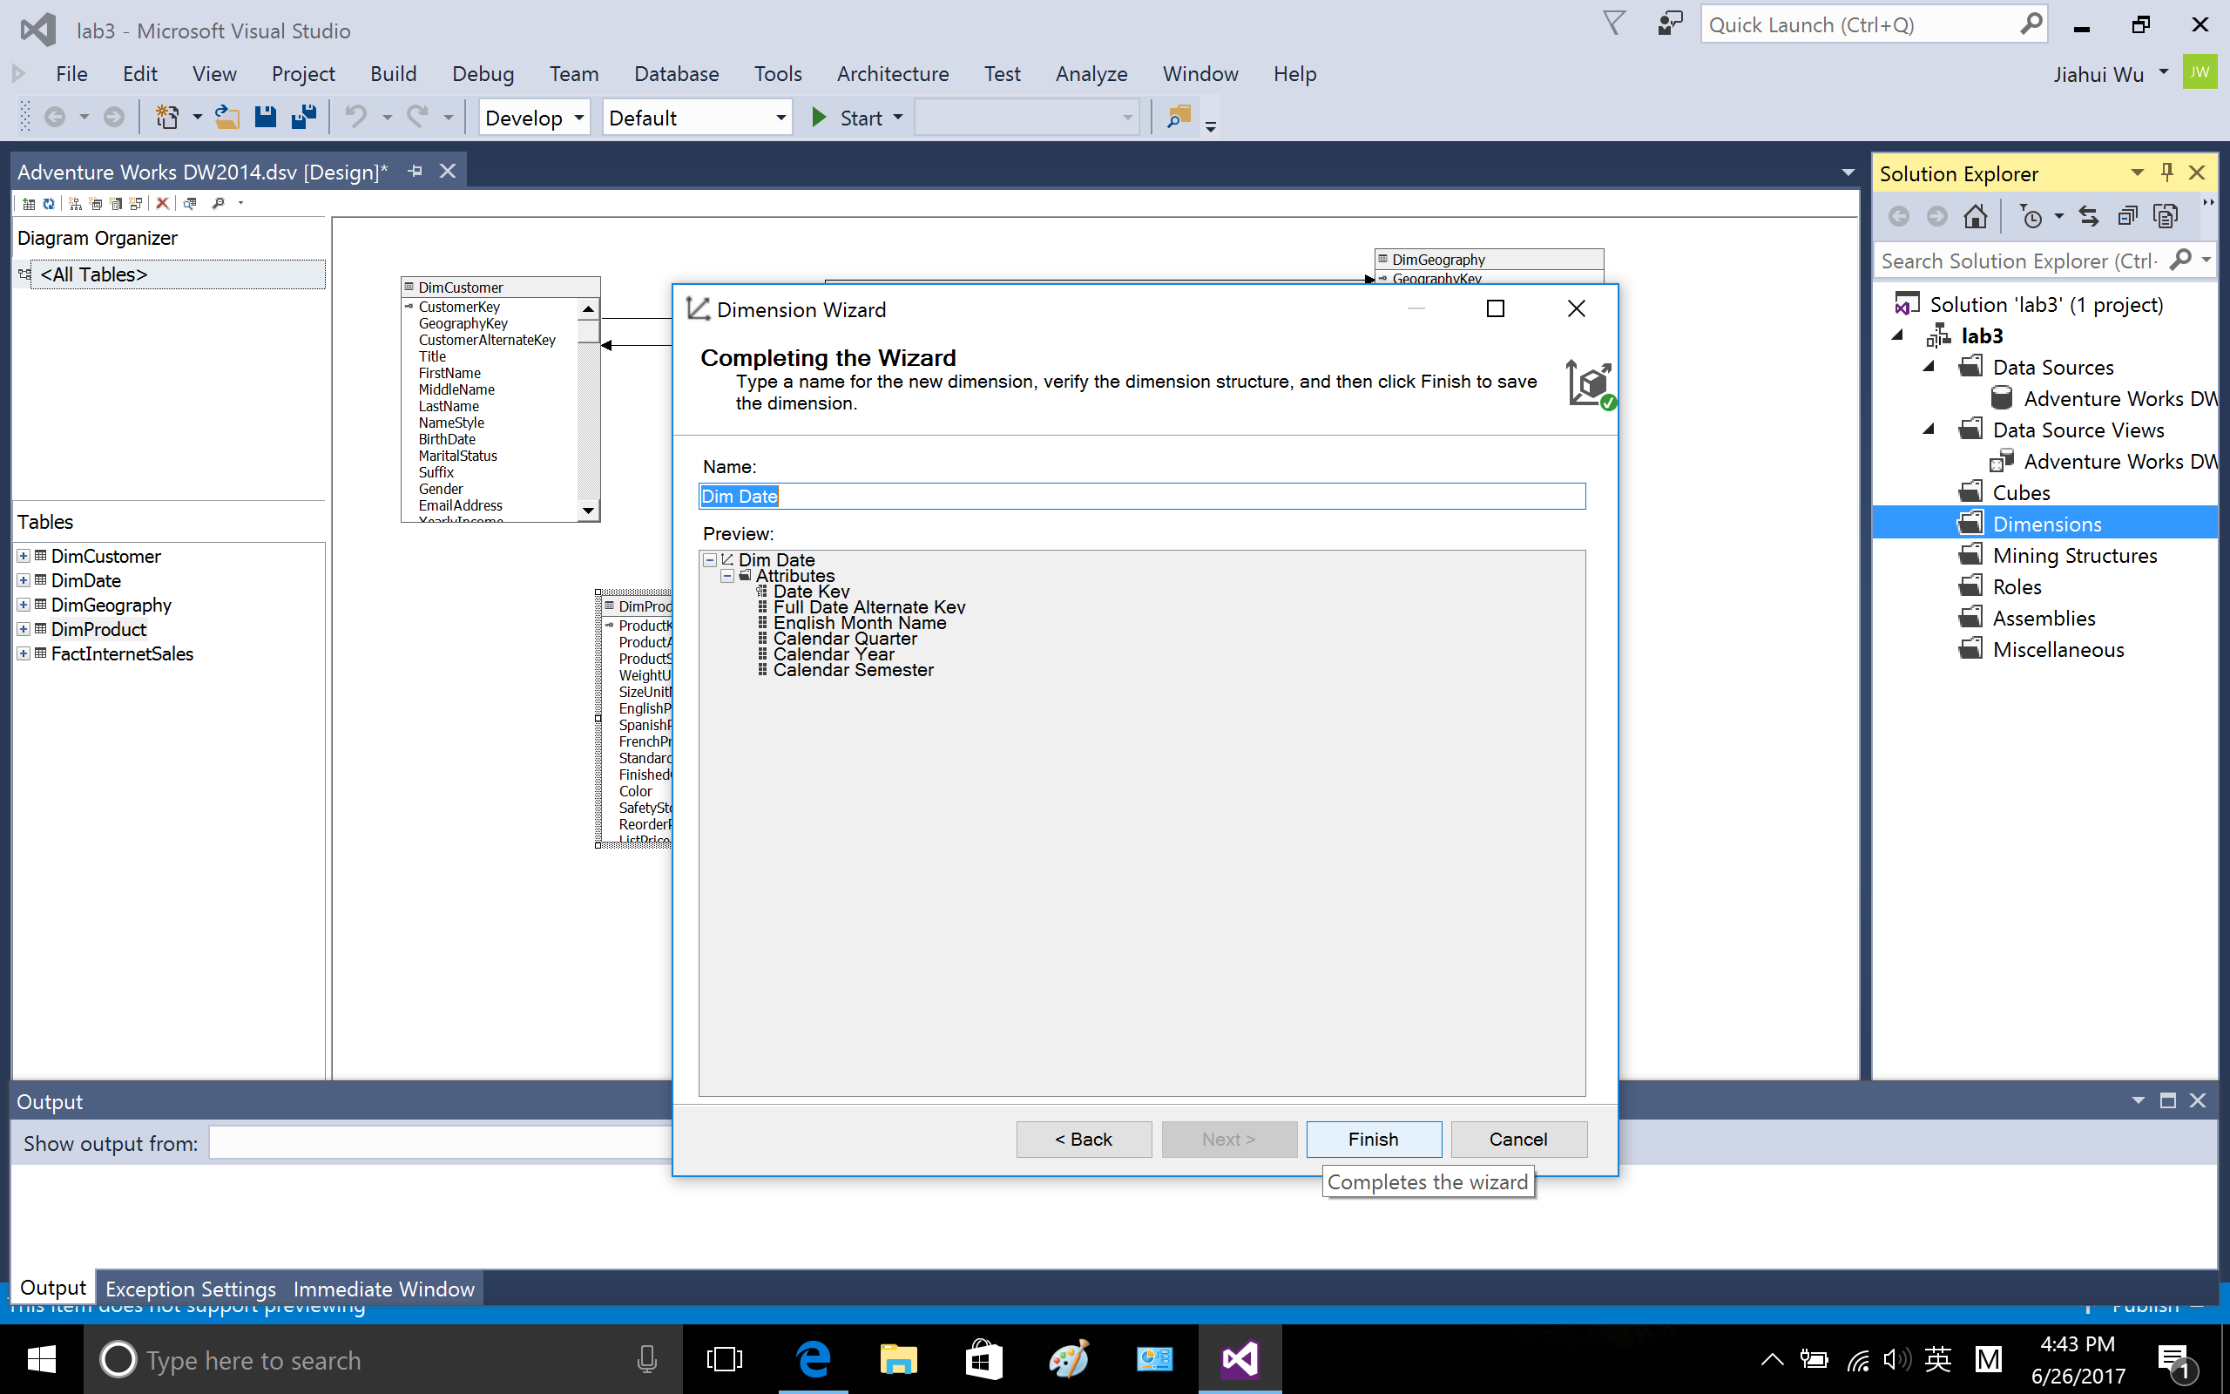

1.5 create cube named lab3

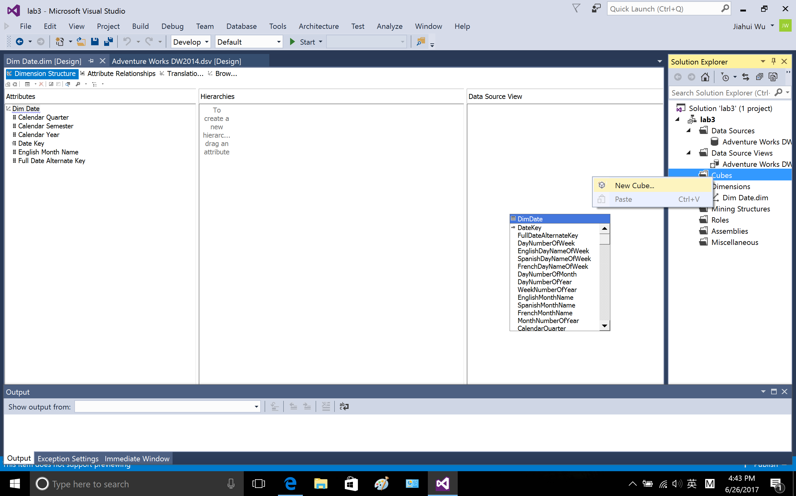

Use existing table

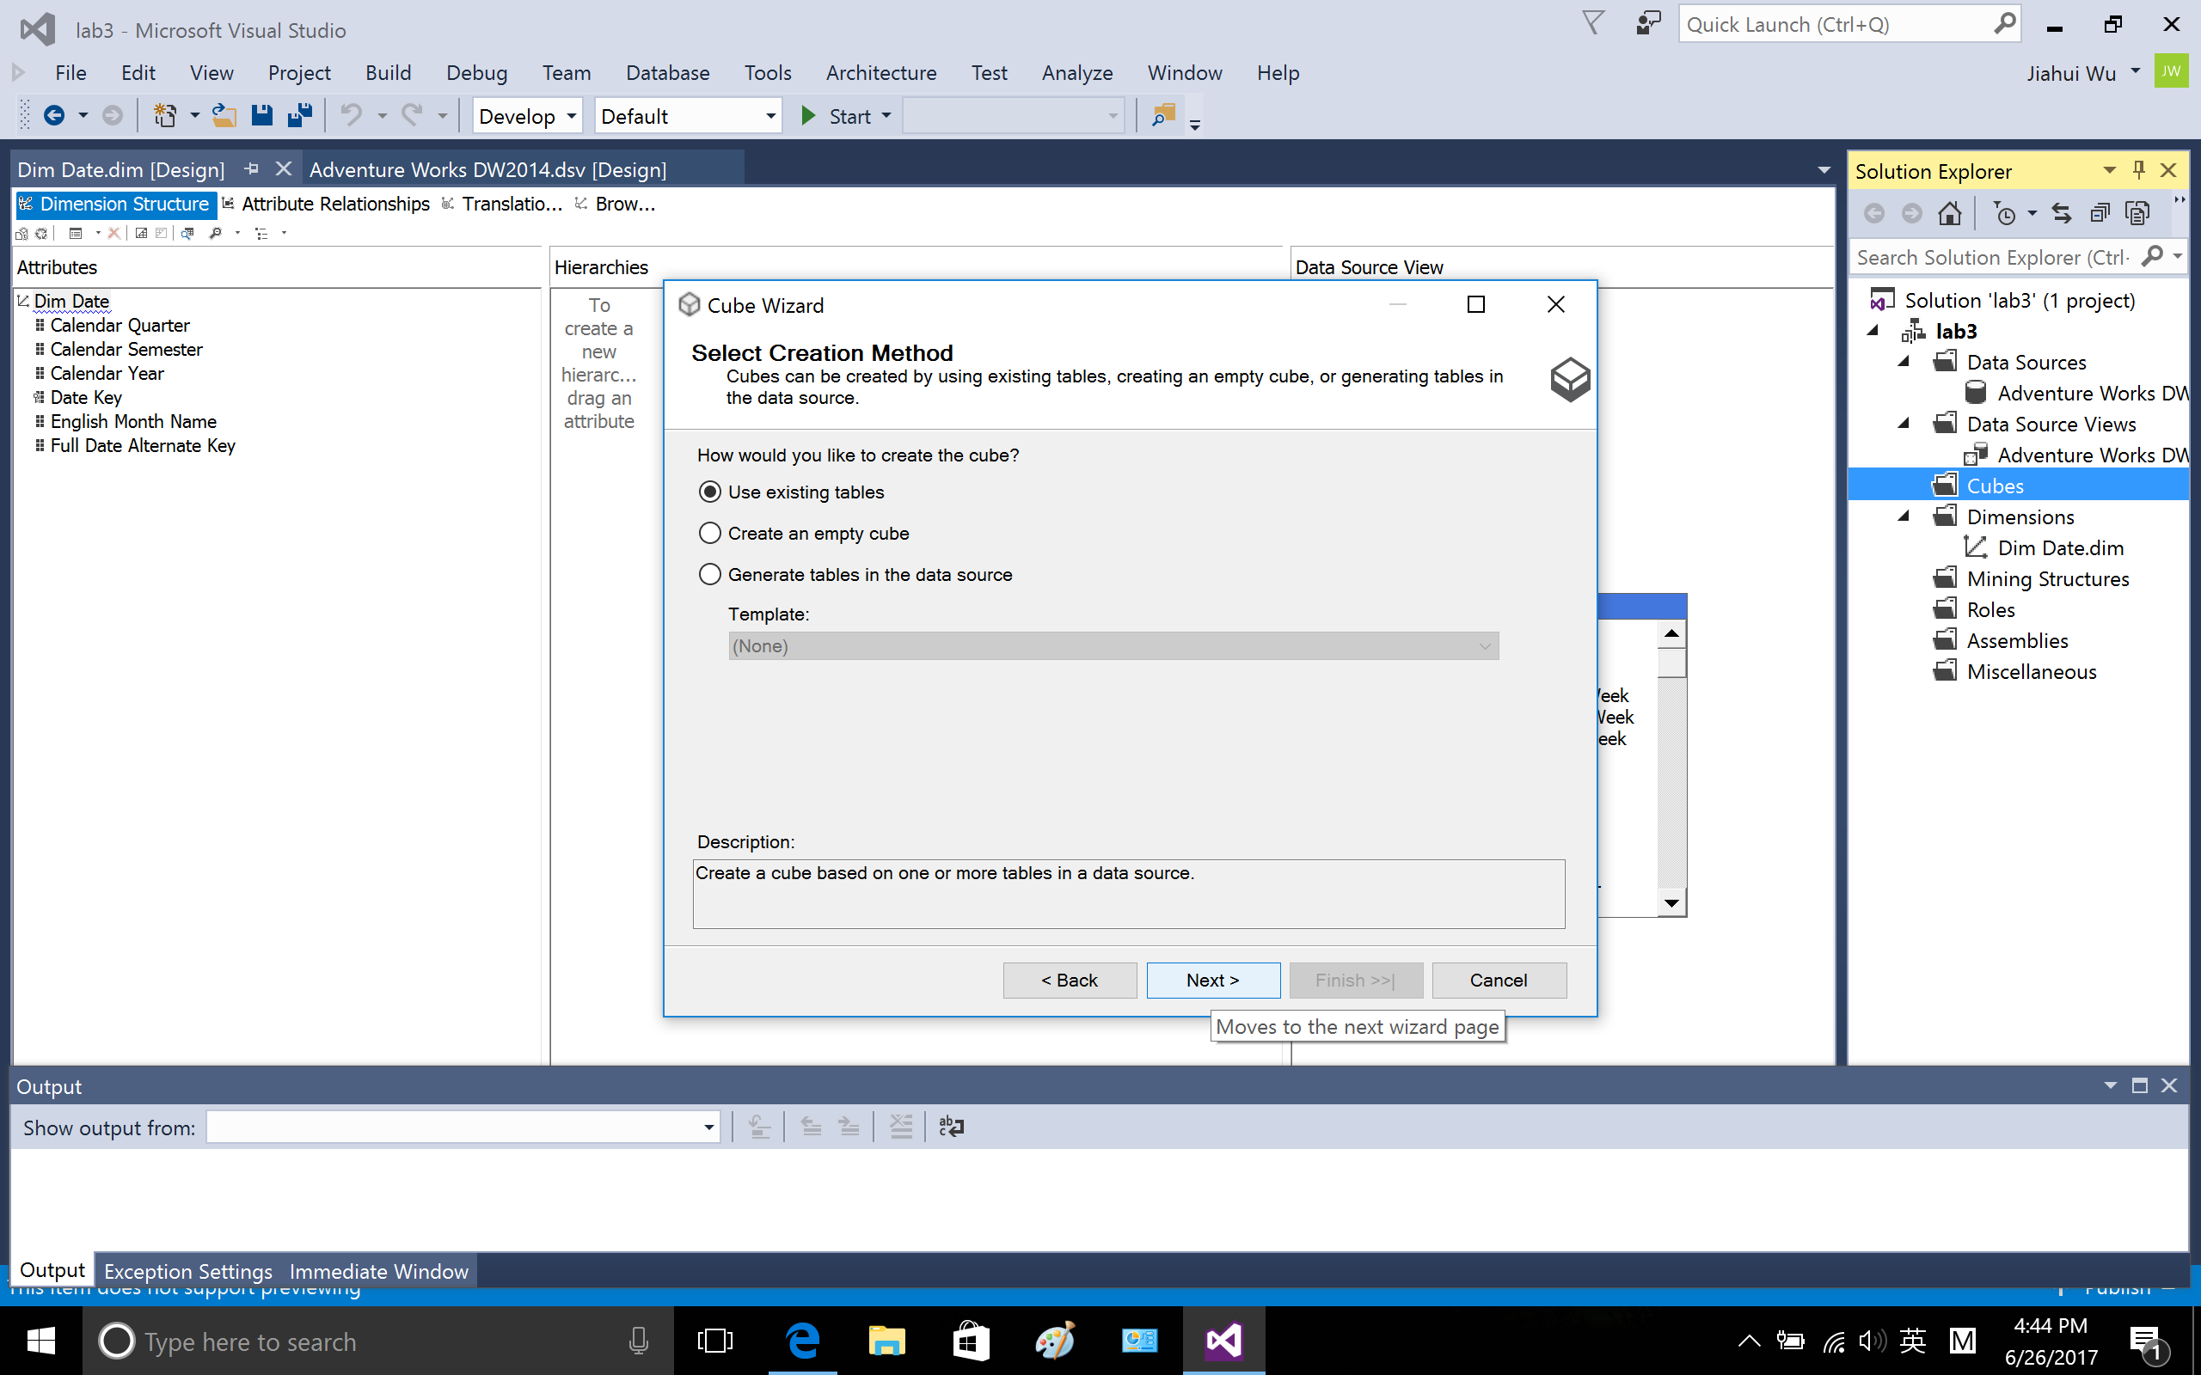

FactInternetSale as measure group

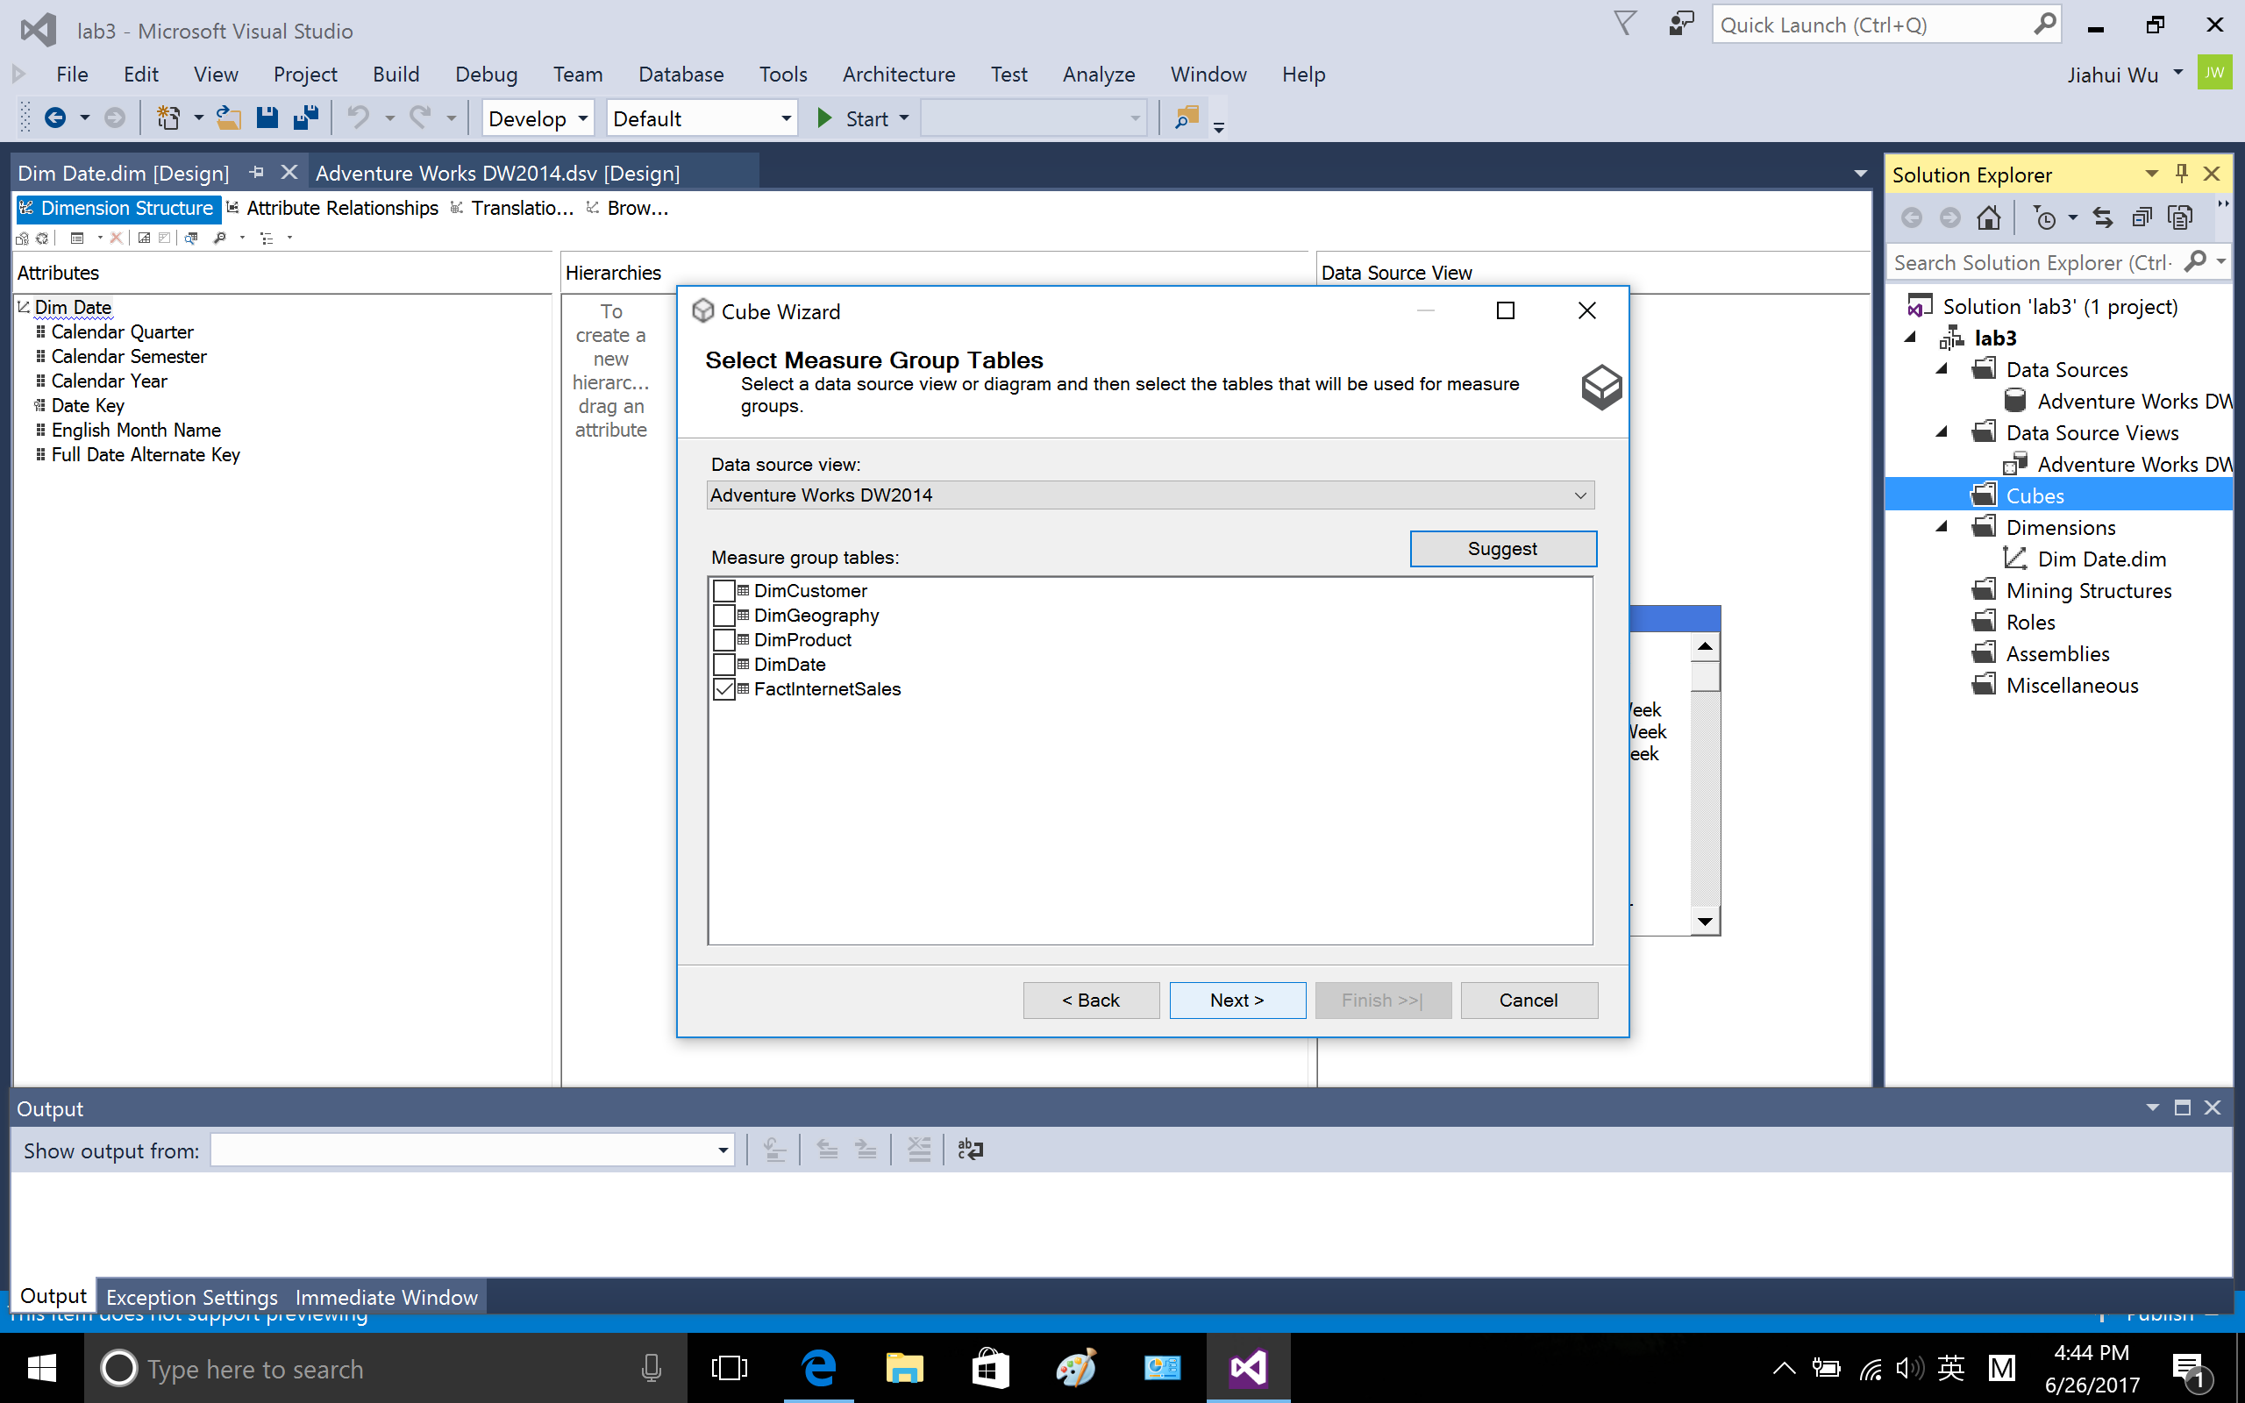

Choose the following attribute for fact table.

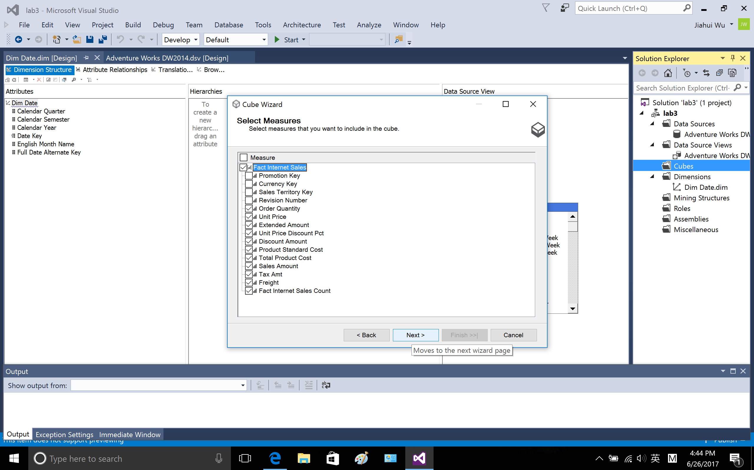

Include the DimDate, whose attribute has been selected before in 1-4

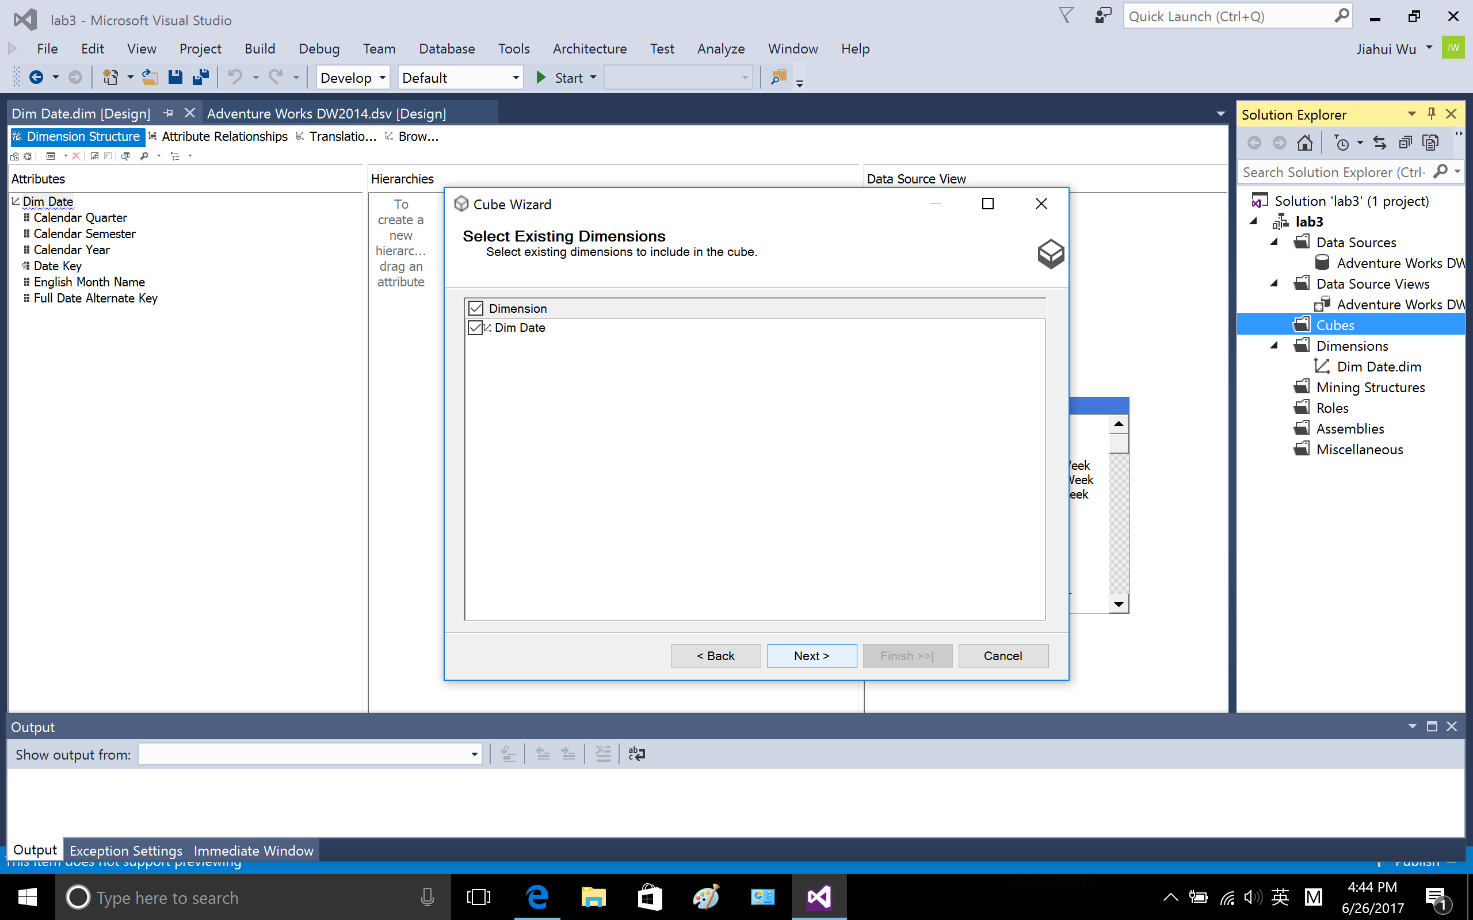

Select all other dimensions

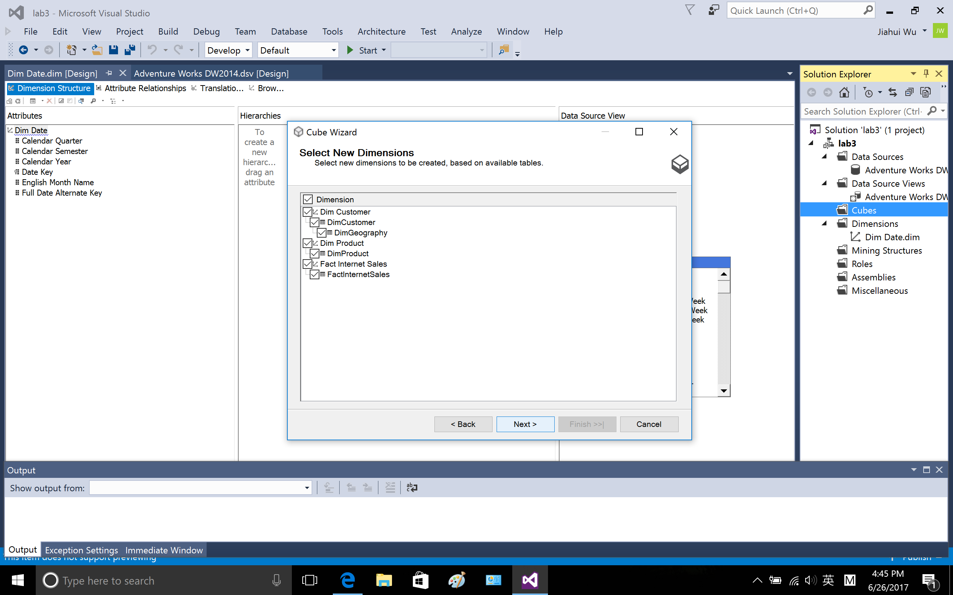

Finish.

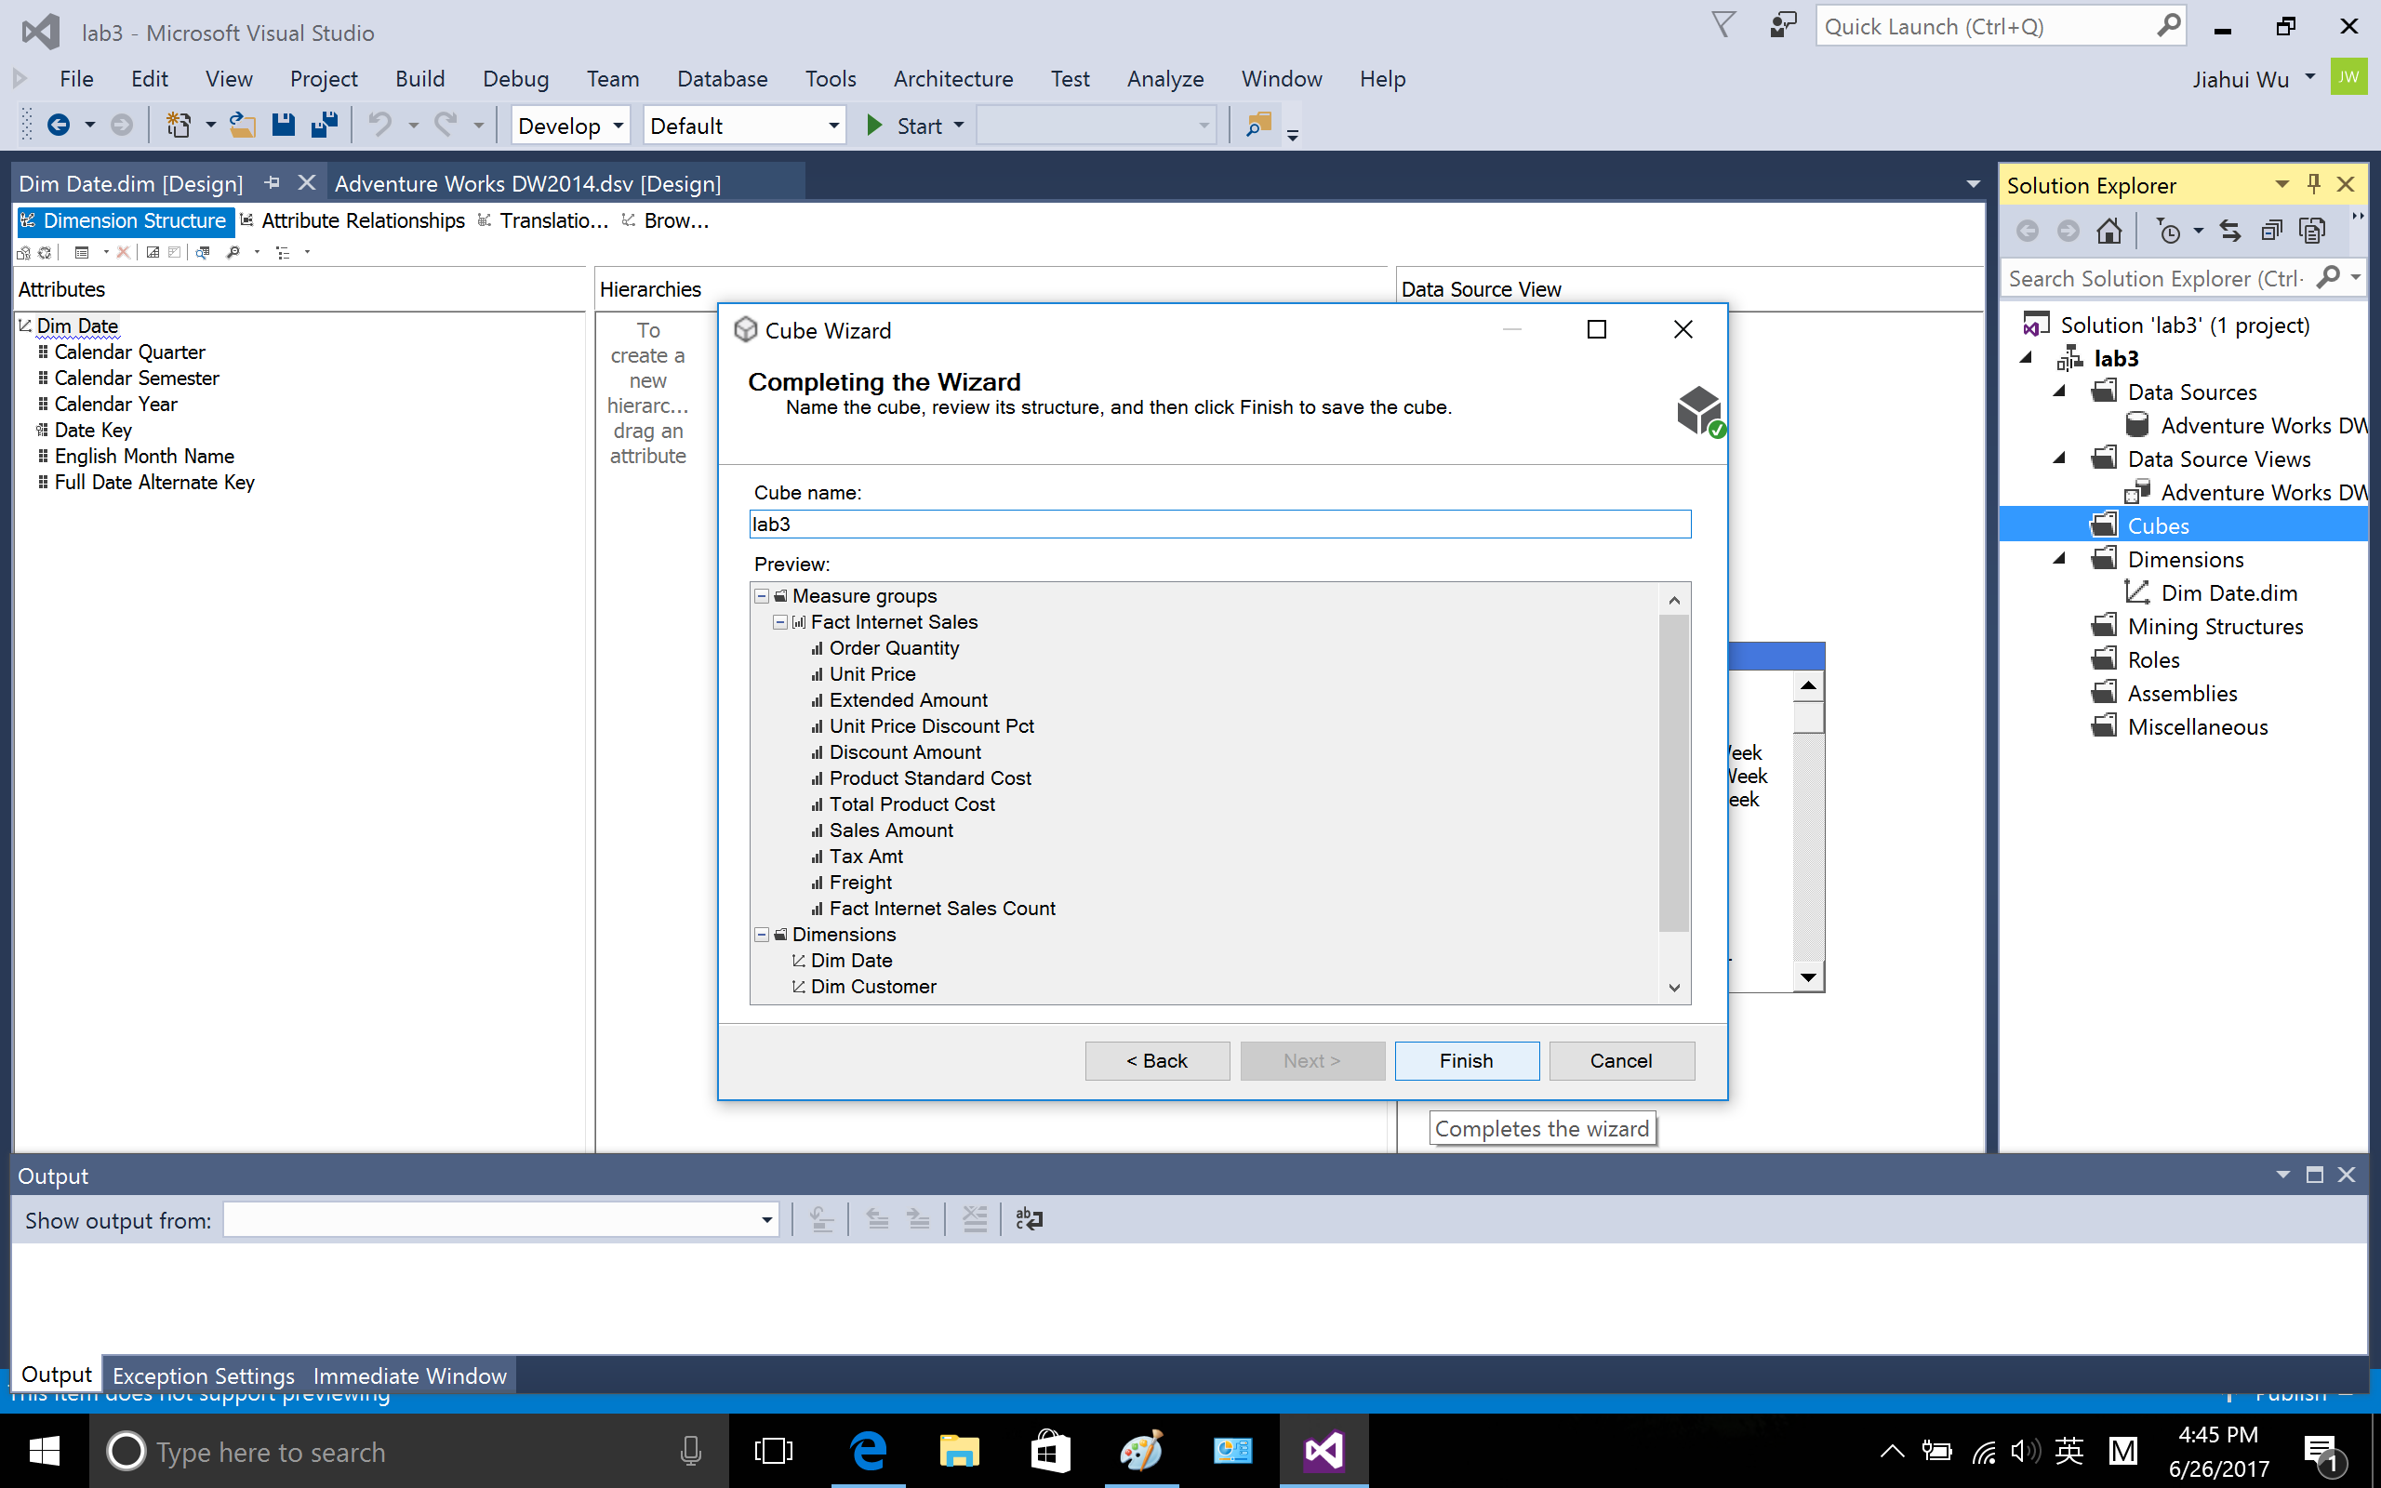

Save the cube

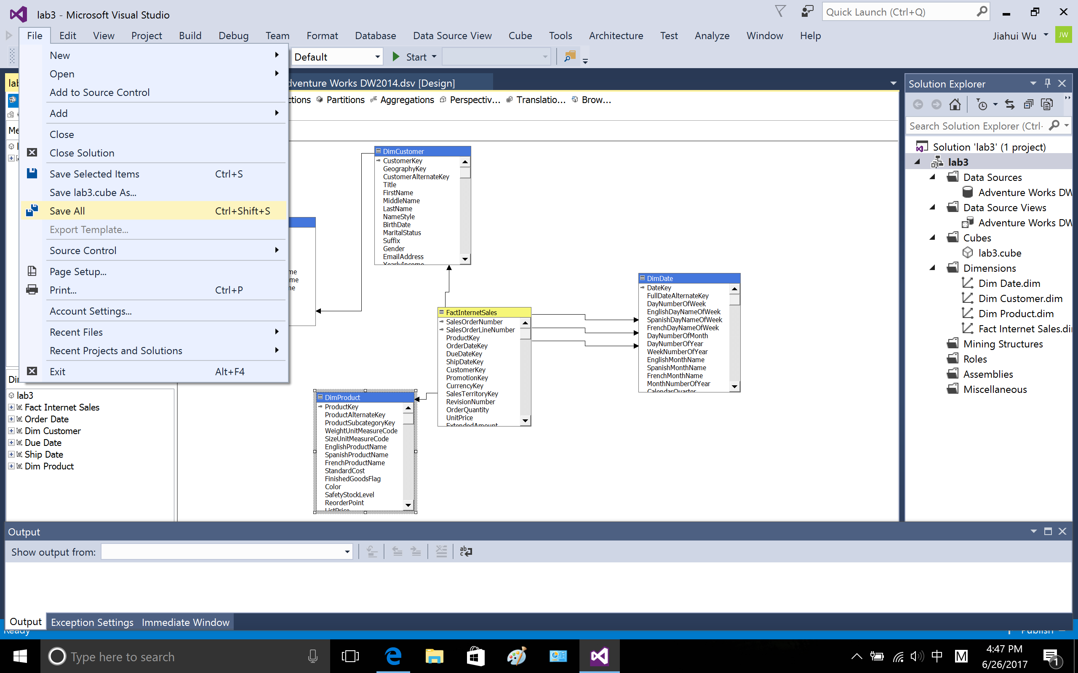

1.6 Add attributes to Dim Customer, drag the attribute from the pane of data source view to attributes pane

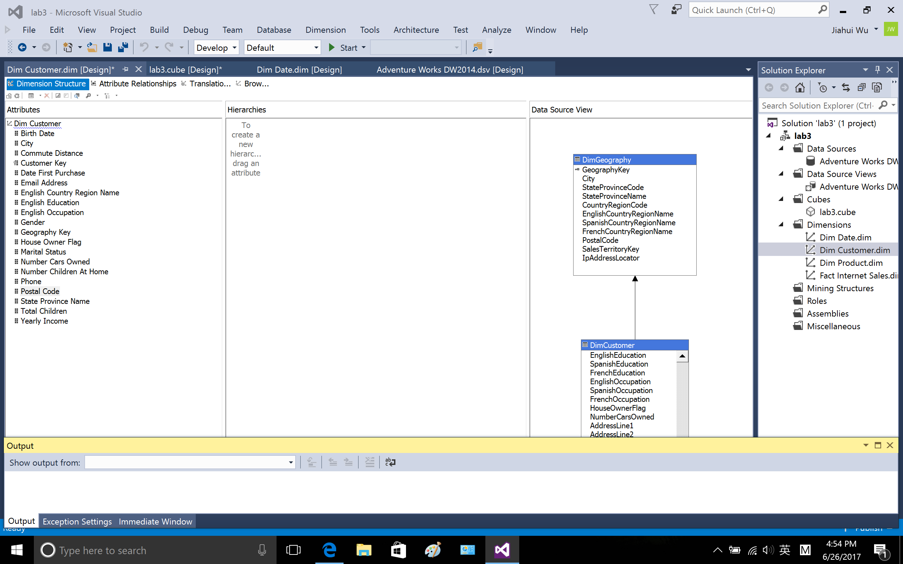

Add attributes to Dim Product

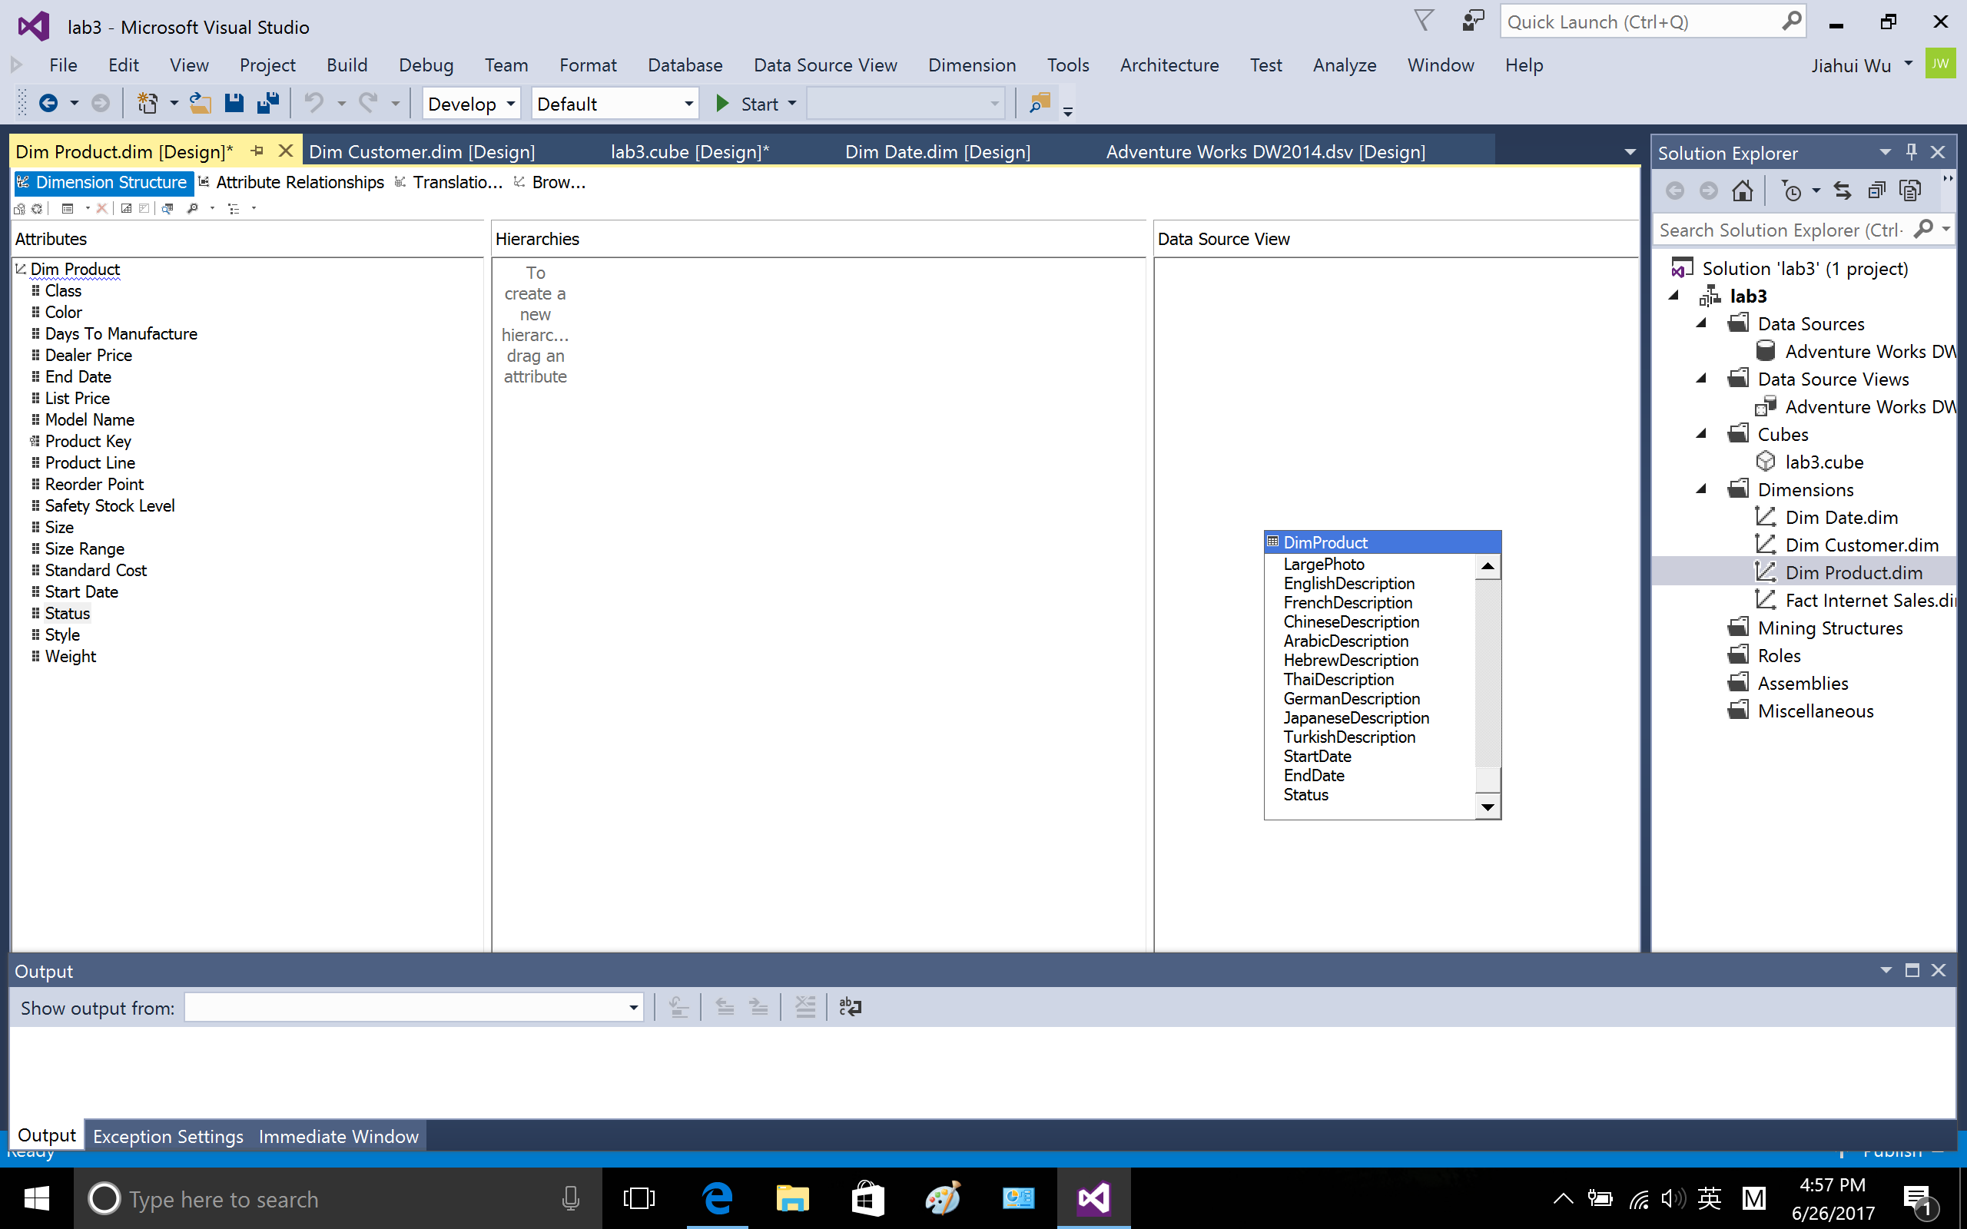

Cube structure of cube [lab3]

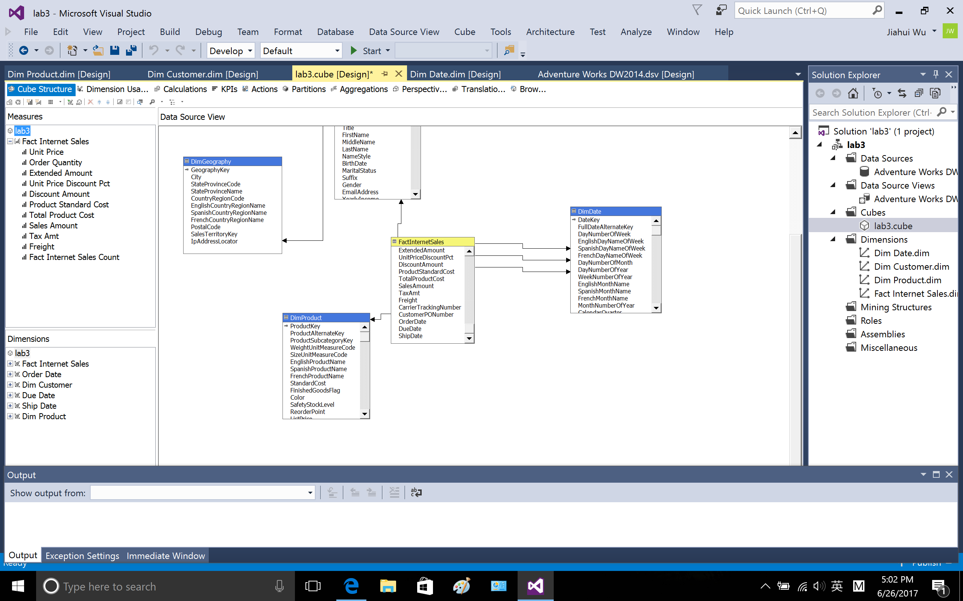

Dimension usage of cube lab3

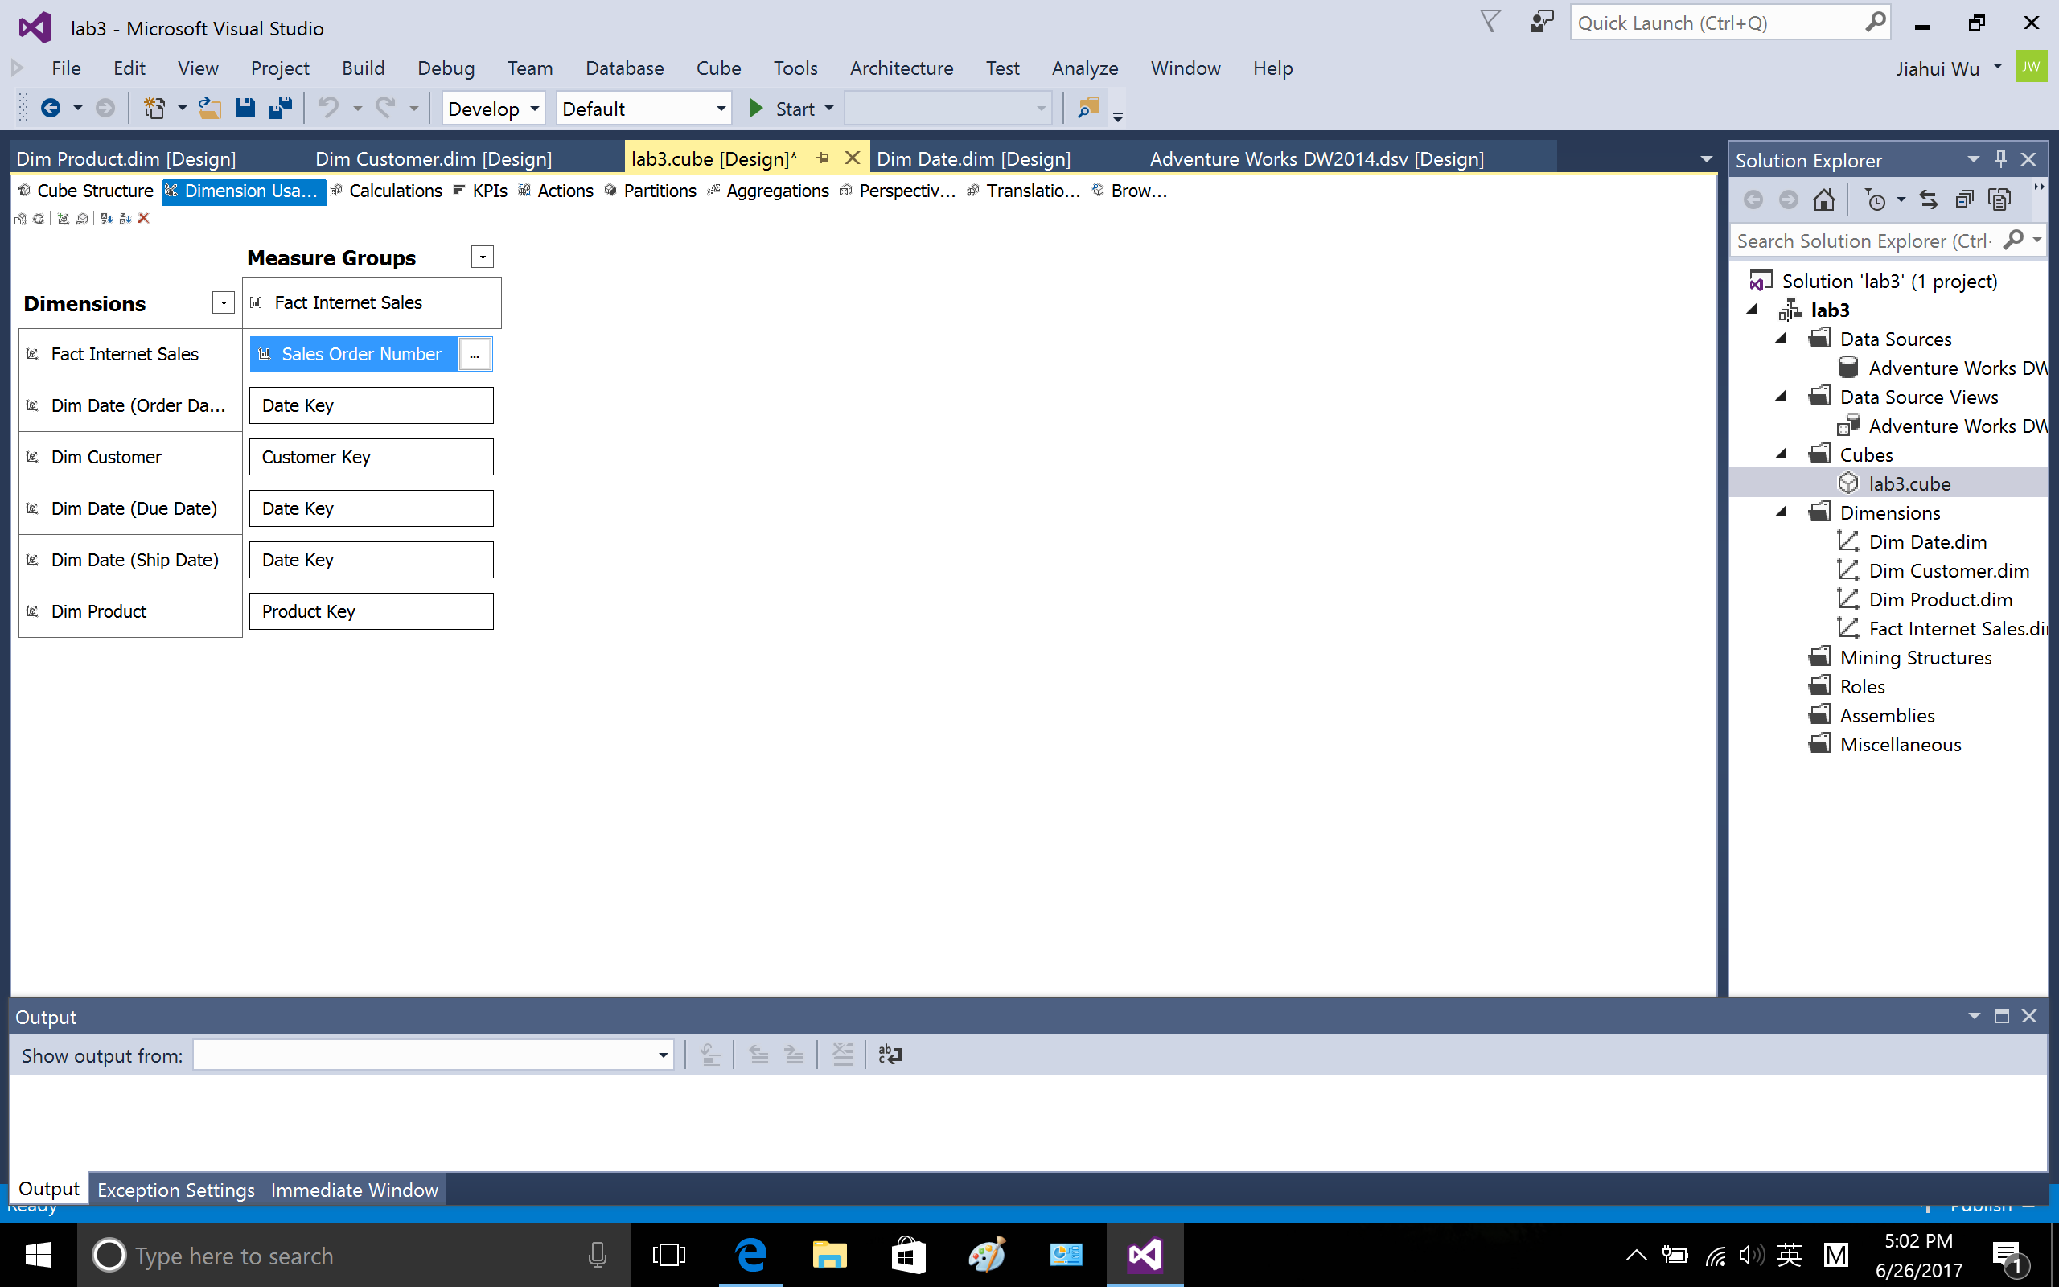

Save

1.7 Process and deploy cube, right click lab3.cube and hit process

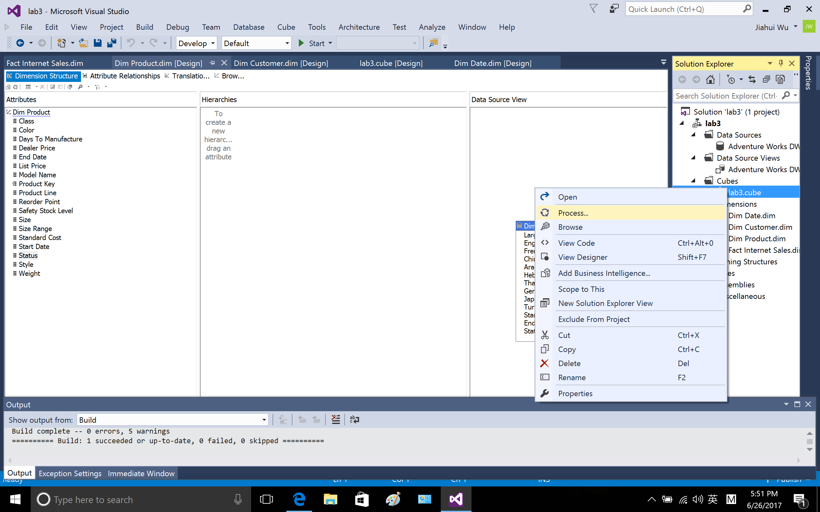

After deployment completed successfully, hit run

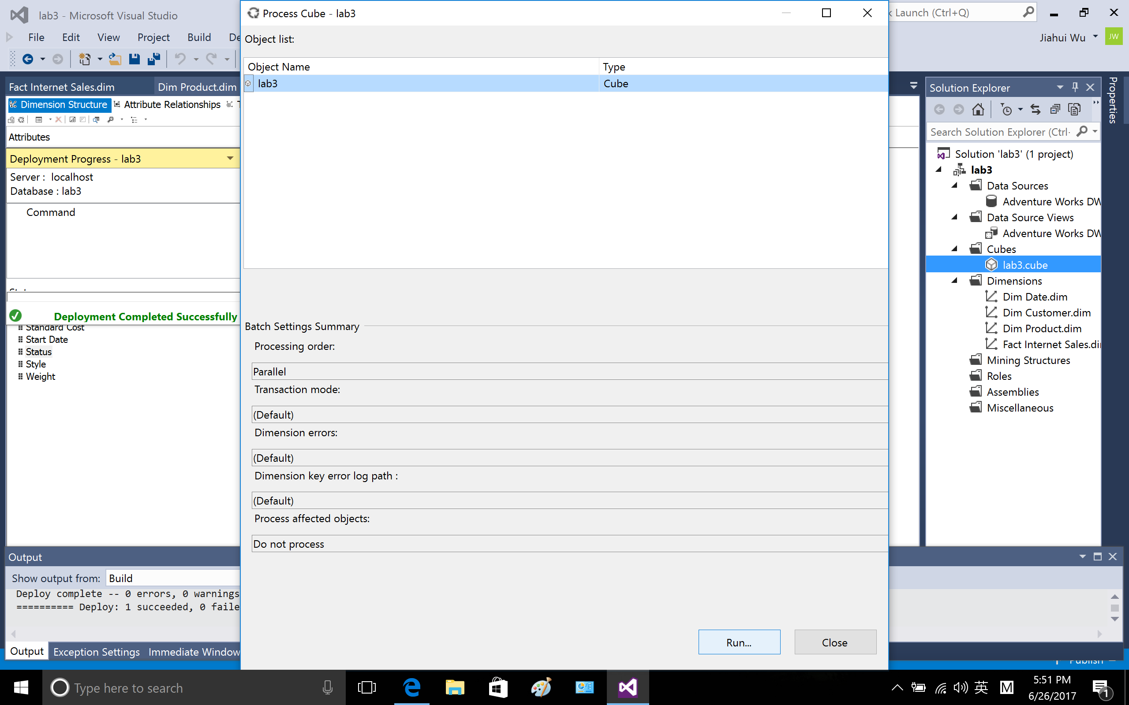

Cube deployed successfully.

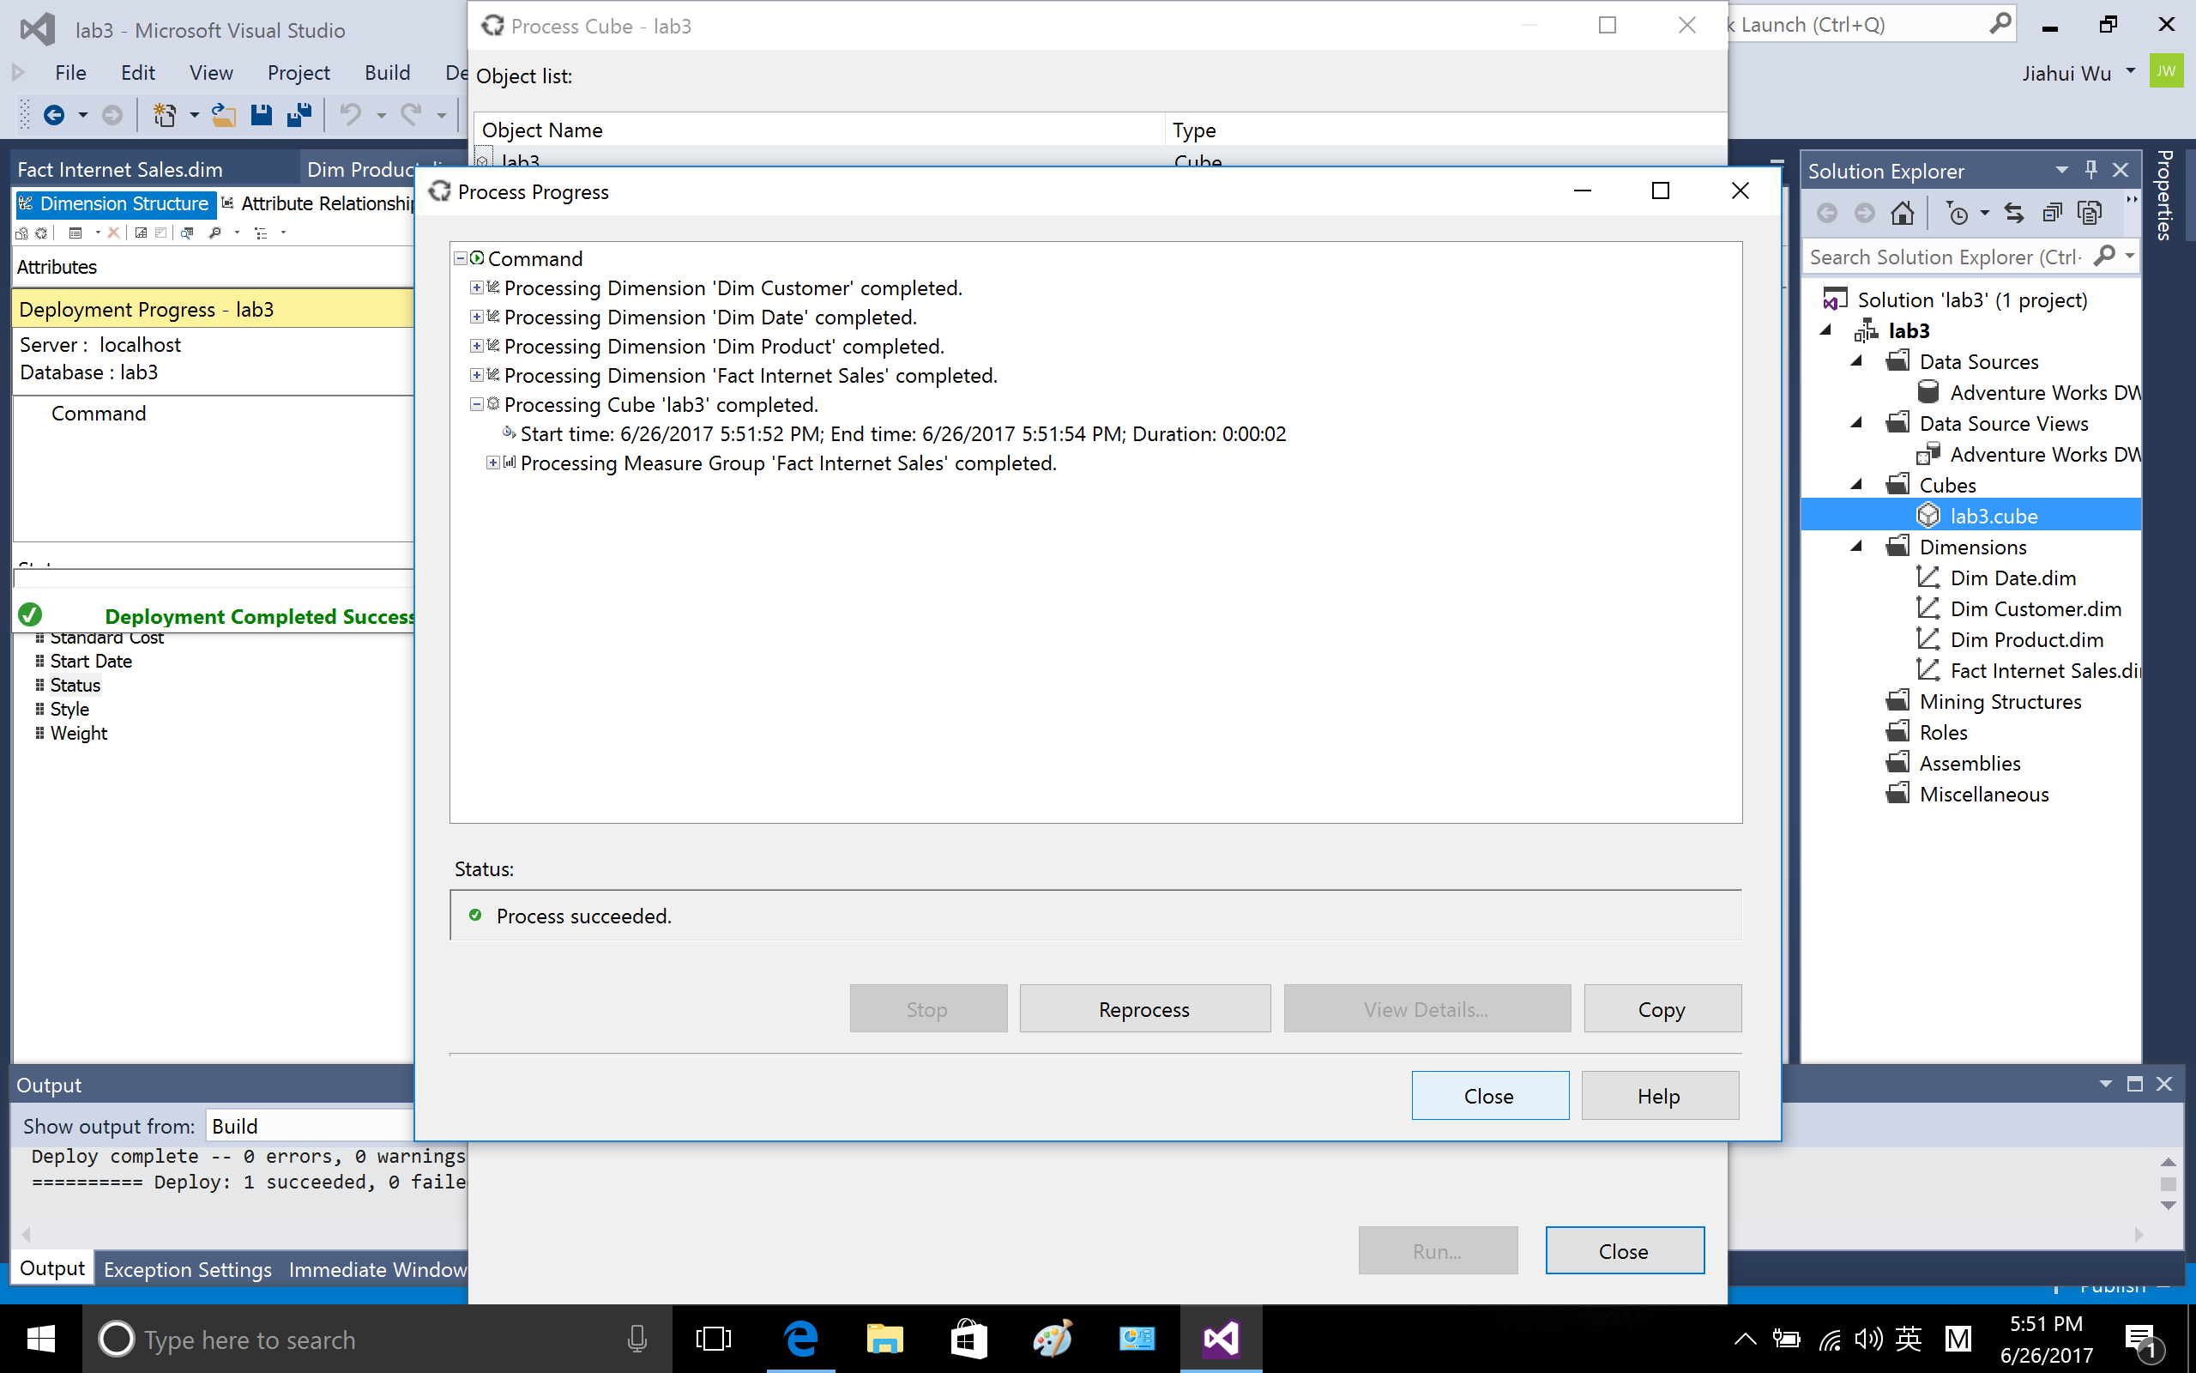

Part 2. Writing MDX queries to retrieve data.

2.1 Connect to SQL server and write MDX query. In the Connect, choose Analysis service

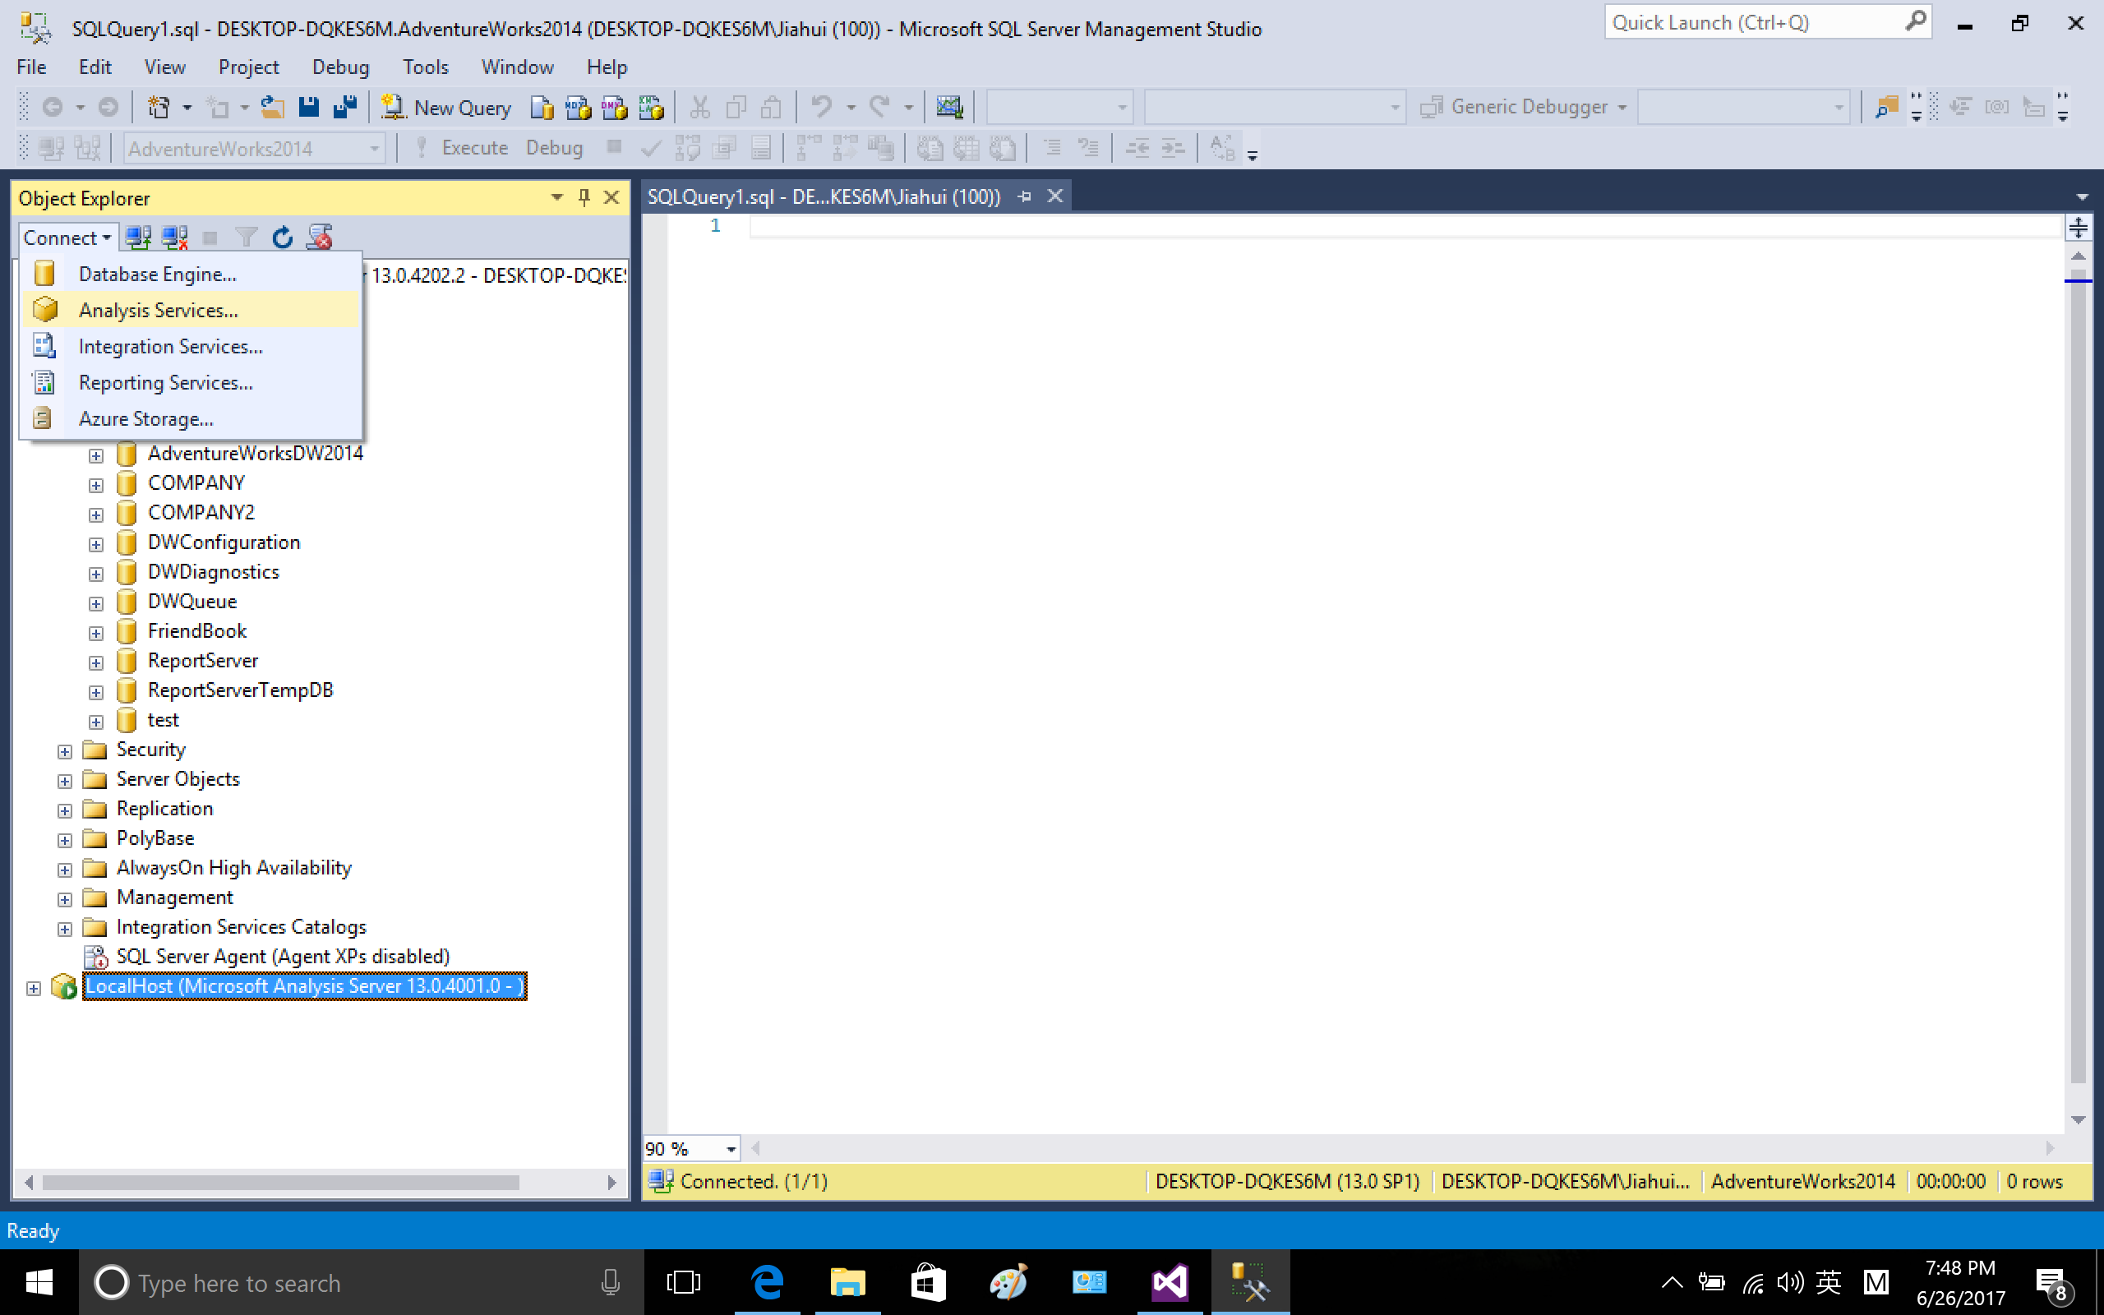

Connect to SQL server, server name type LocalHost

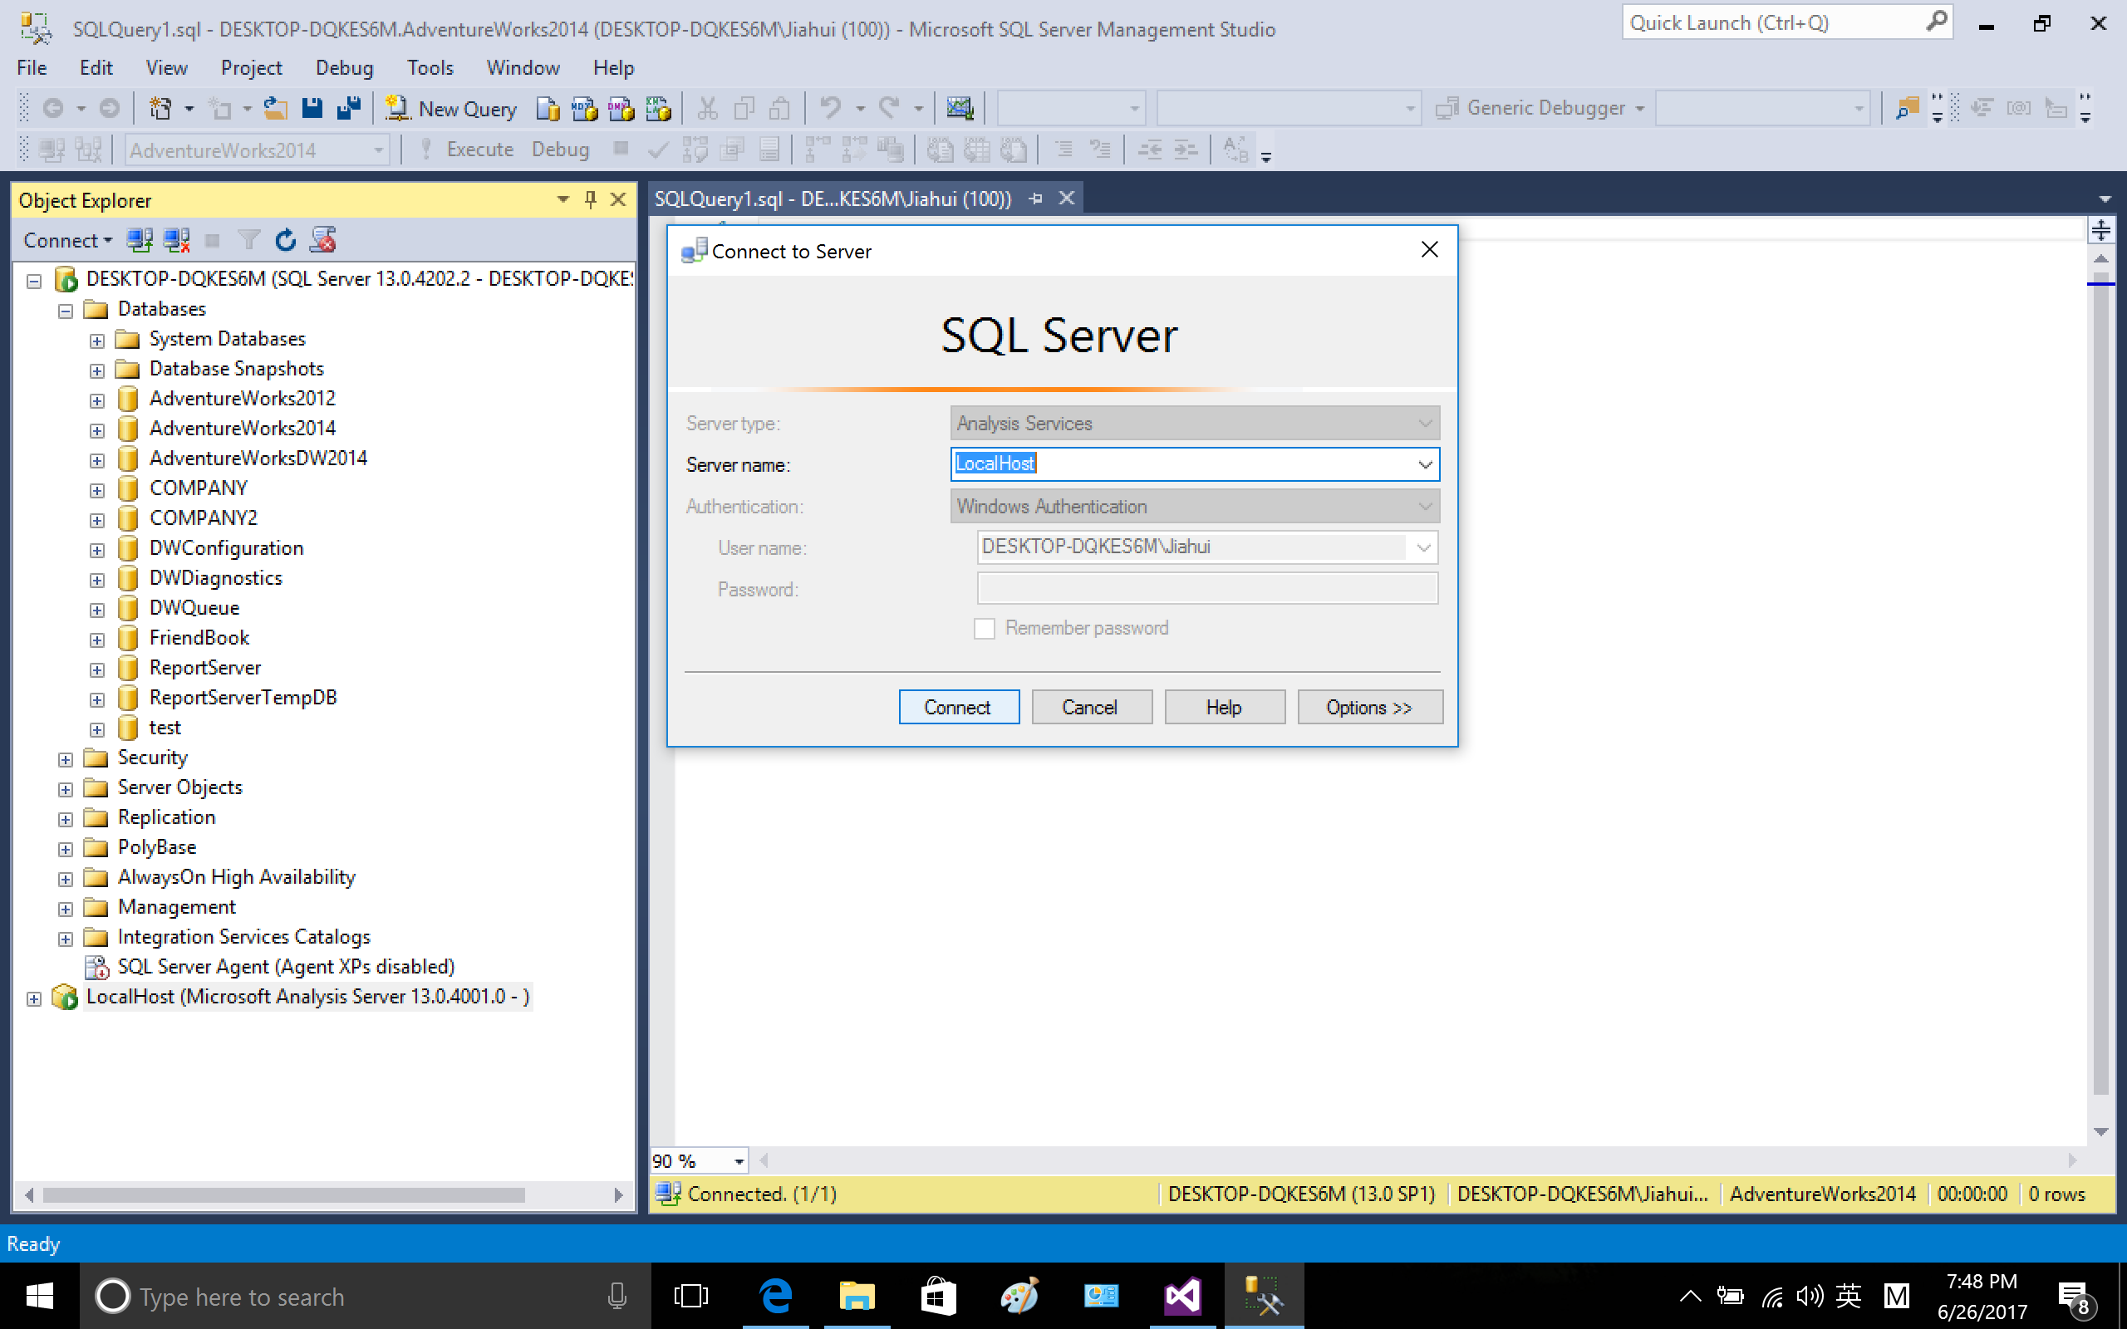

Right click lab3.cube and create new MDX query

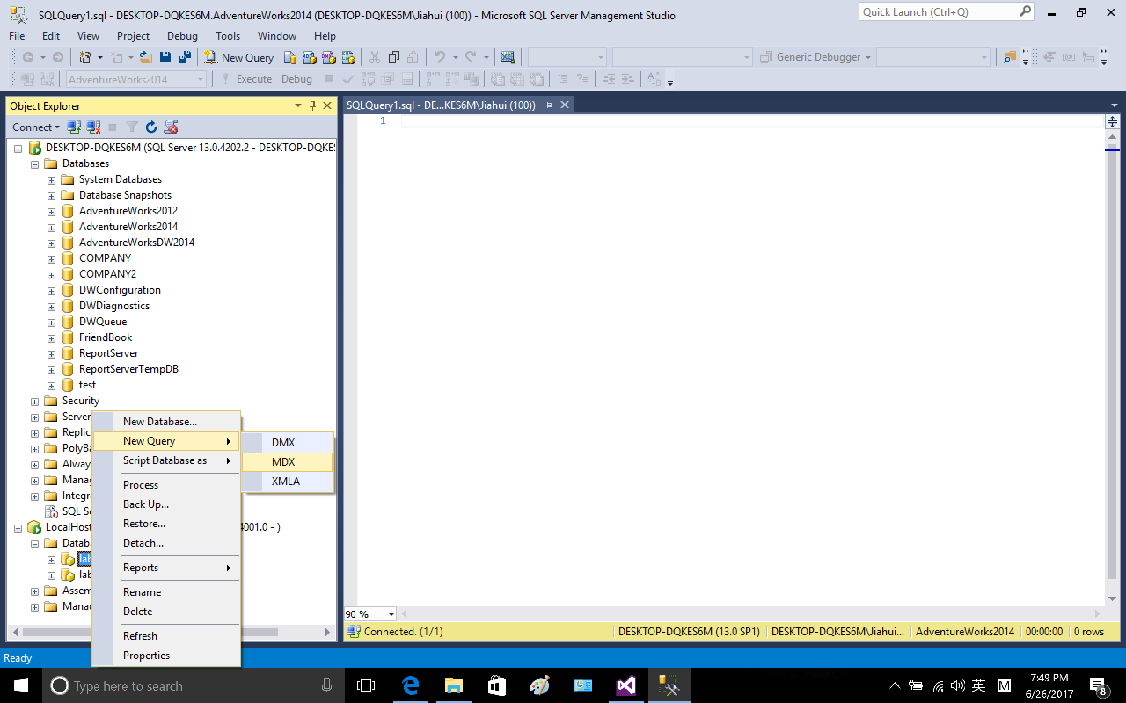

In the middle pane, we could expand each dimension and see all the attributes, for example

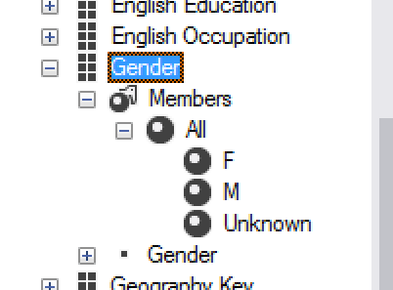

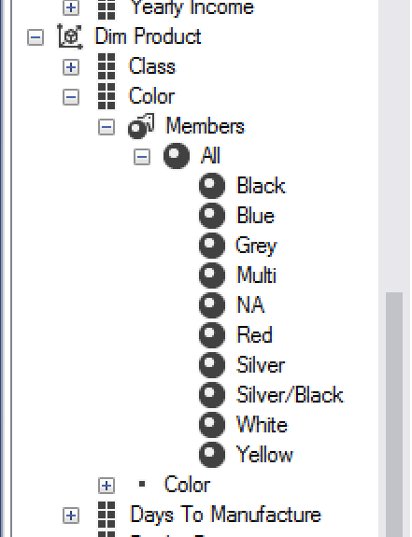

2.2 Predict the color of each bike depending on the gender.

We want to see the relation between bike color and gender.The following query shows a table, the columns are gender (F, M, unknown), rows are bike colors (black, white, etc)

From the result, we can see there is NO color-preference between male and female. The order quantities are comparable. The most popular color is black.

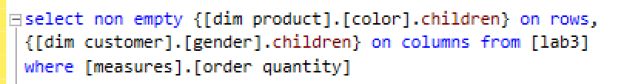

Result

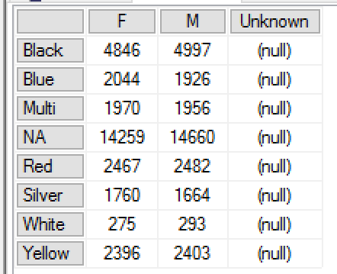

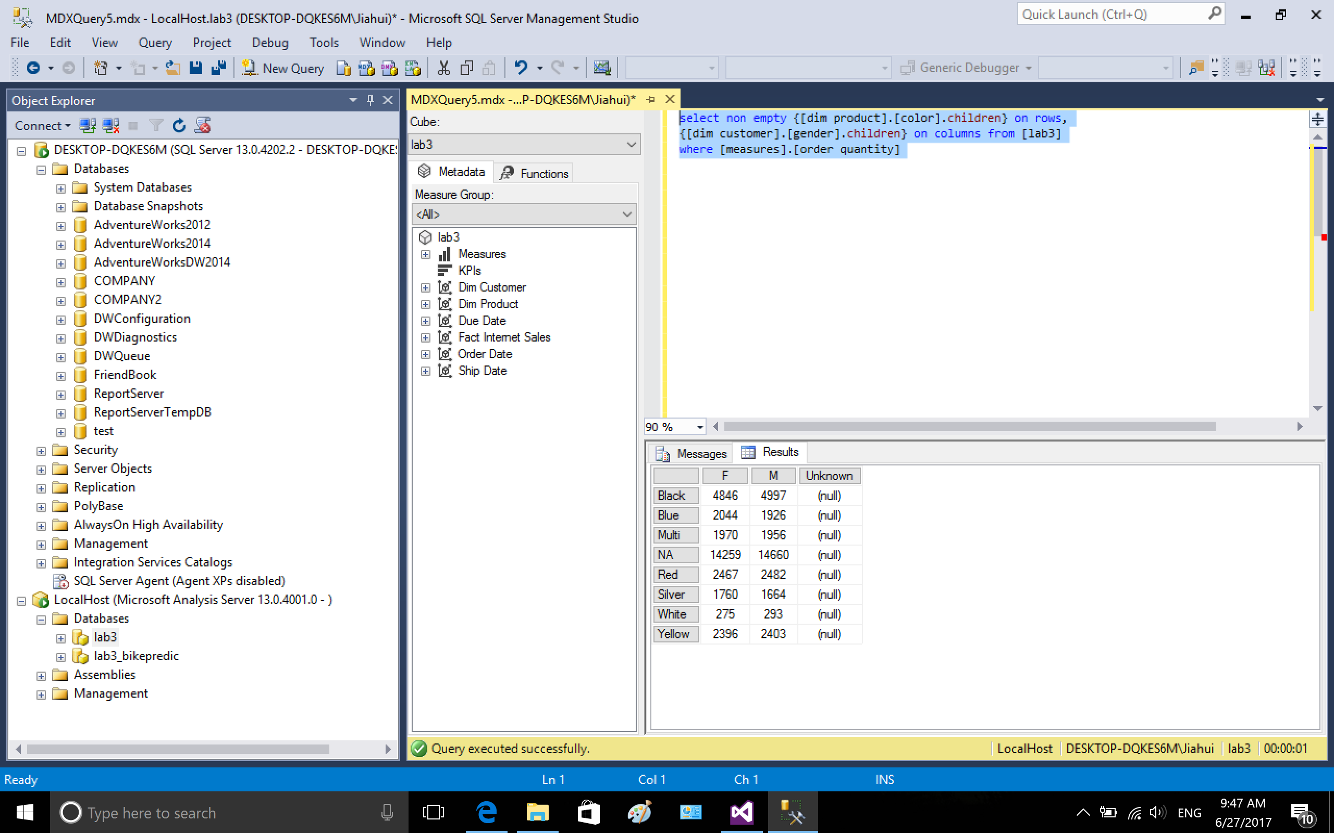

2.3 Predict which cites we need bike supply for next year (the reason for using 2013 is discussed in part3 trouble shooting)

I use function TopCount to count the top 10 best selling cities. From the result, we could see that London, Paris, Cliffside, Berlin and Burien are top 5 cities where bikes are sold most in quantity.

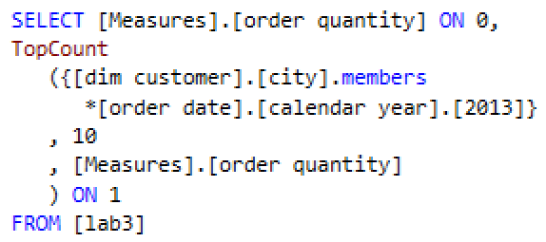

result

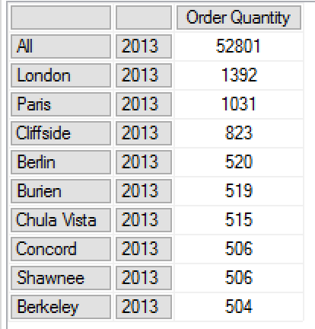

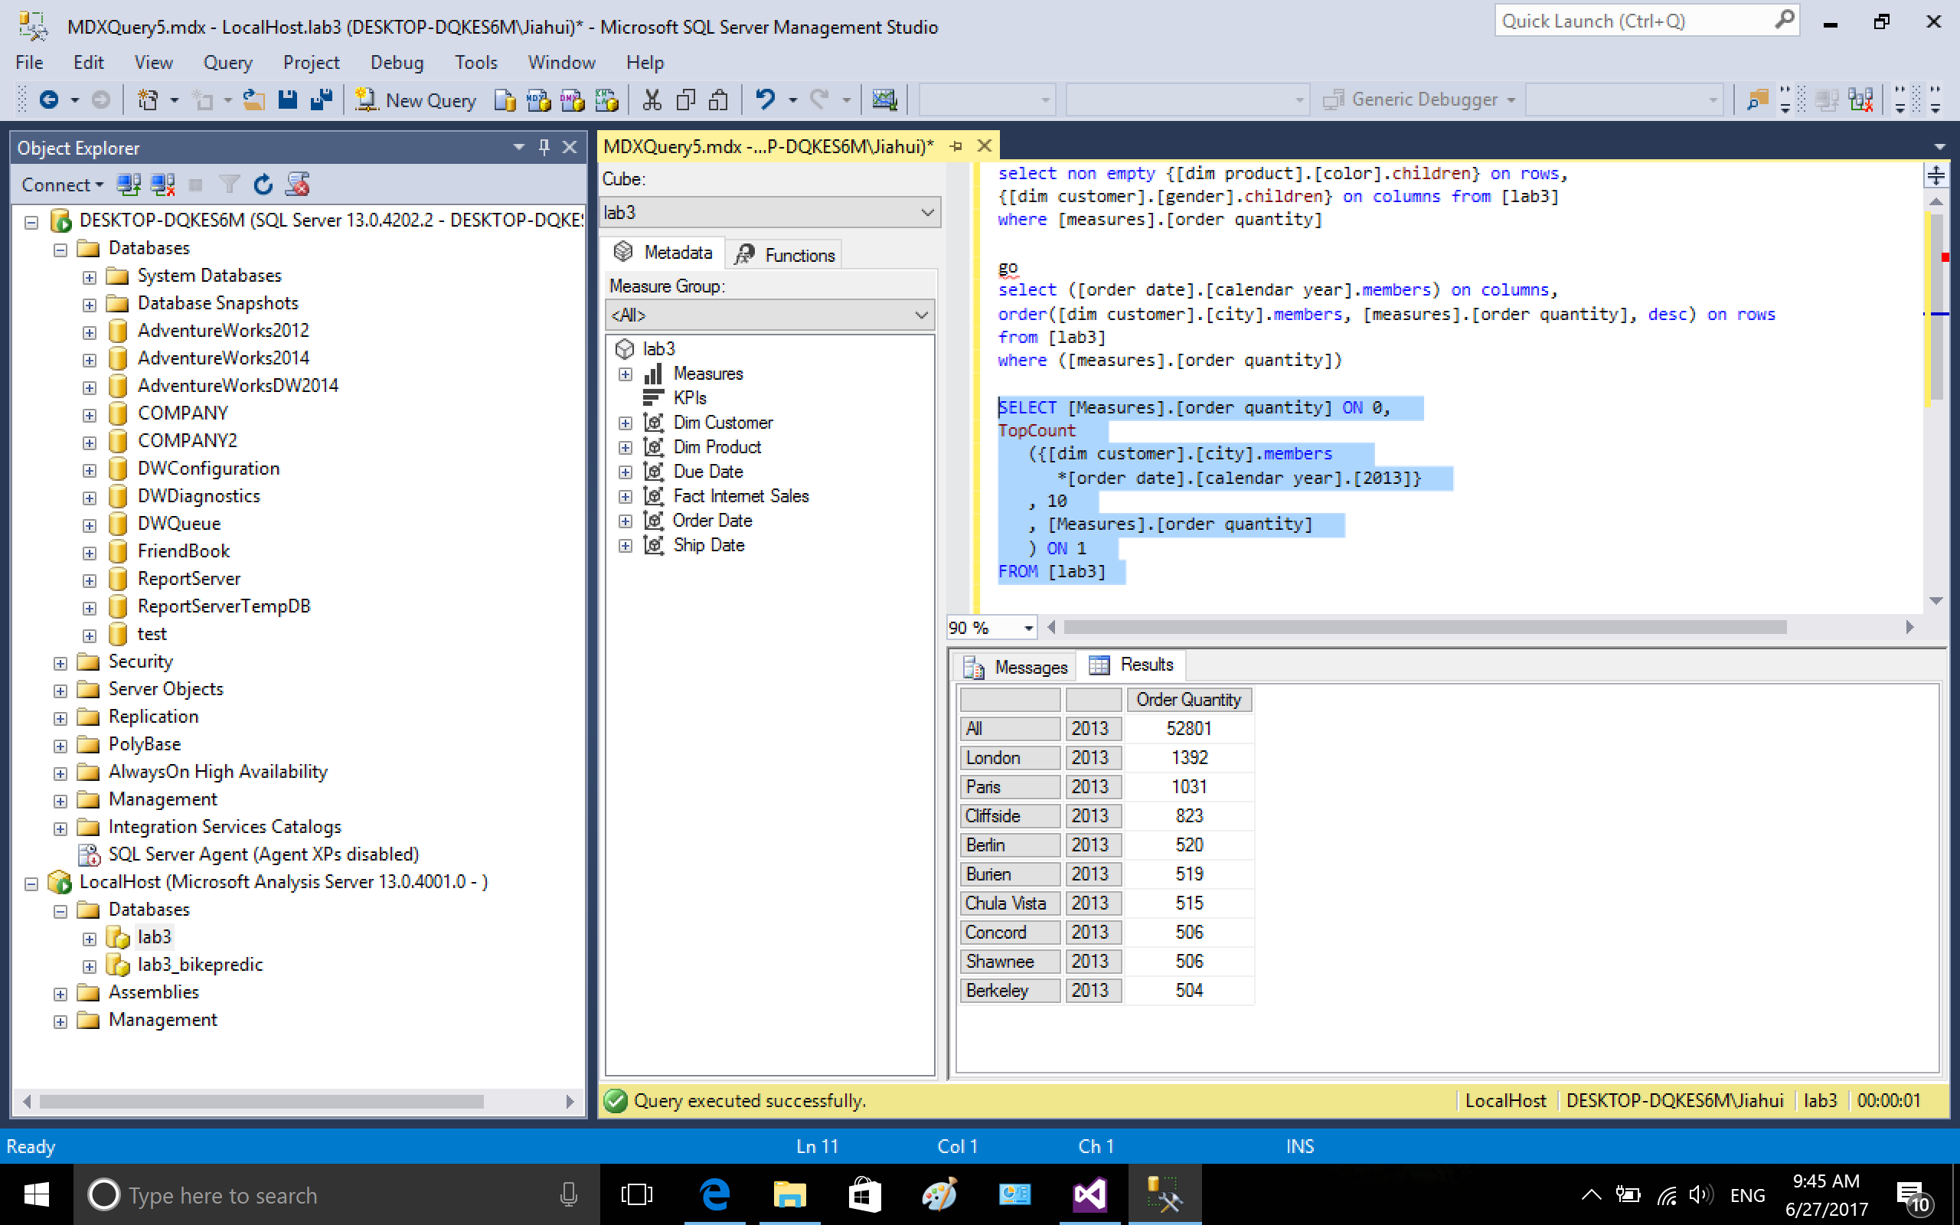

2.4. drill down to each quarter in year 2013

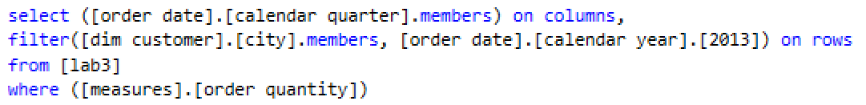

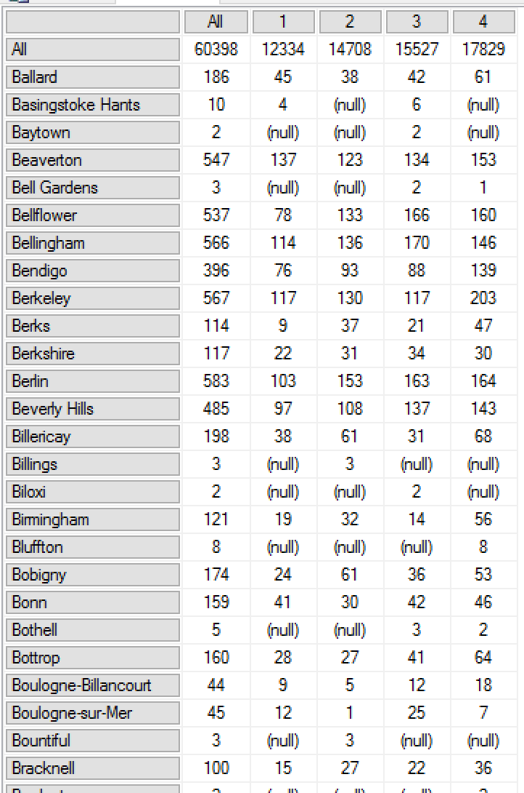

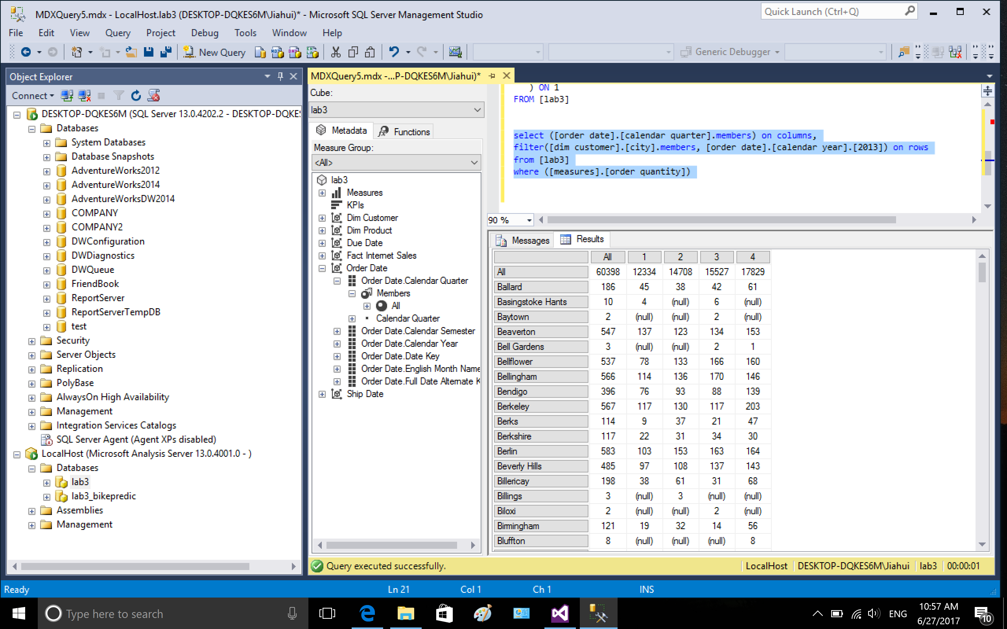

Copy the data to excel and sort by Column All

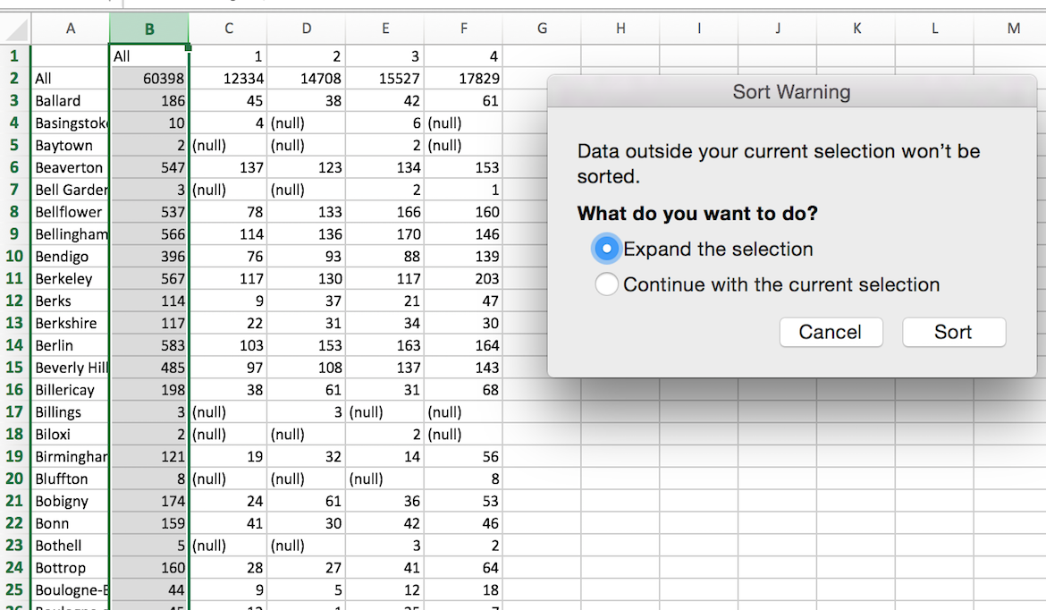

Select the cities with more than 500 bikes sold in year 2013.

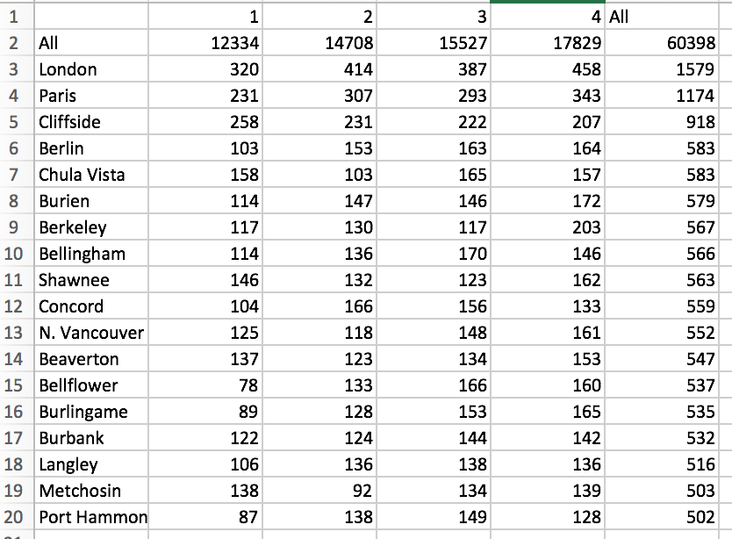

plot the scatter graph for All cities and individual cities.

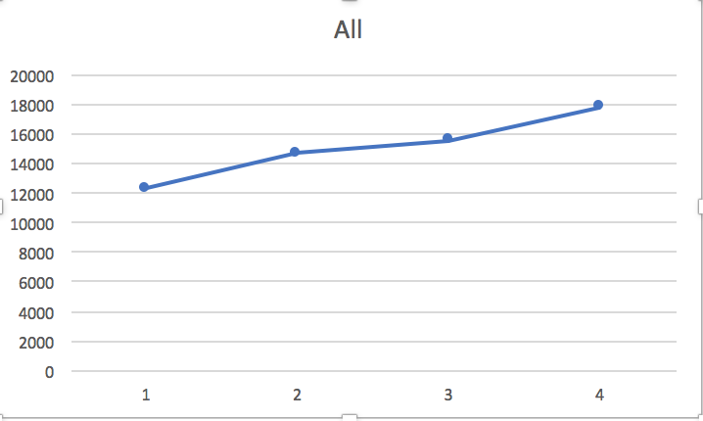

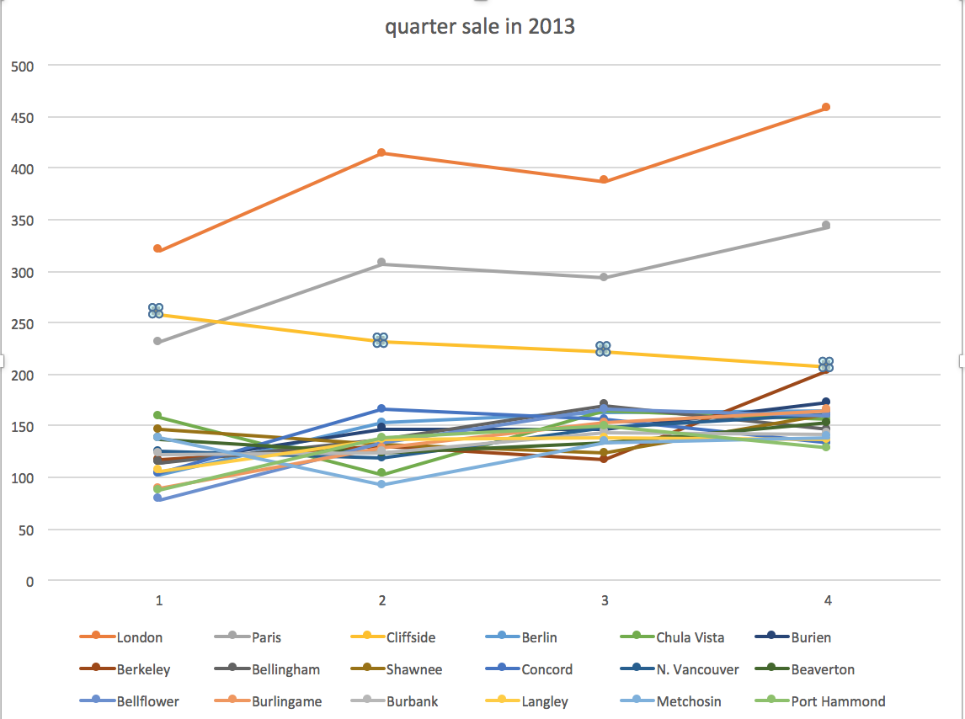

From the graphs we can see that the sales of bike is in increasing order along with the quarter, usually the 4th quarter of the year has the most sales among quarters. Maybe it is because of shopping season and holiday season, people tend to spend more money.

However, from the plot we can see some cities have downward tendency, for example, city Cliffside and Bellingham, the number of bikes sold in the 4th quarter is less. Analyst should consider this unusual trend and make adjustments accordingly.

2.5 drill down to month in year 2013

The query is the almost the same as 2.4, the only difference is using month instead of quarter.

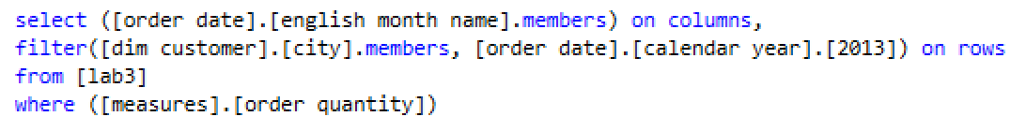

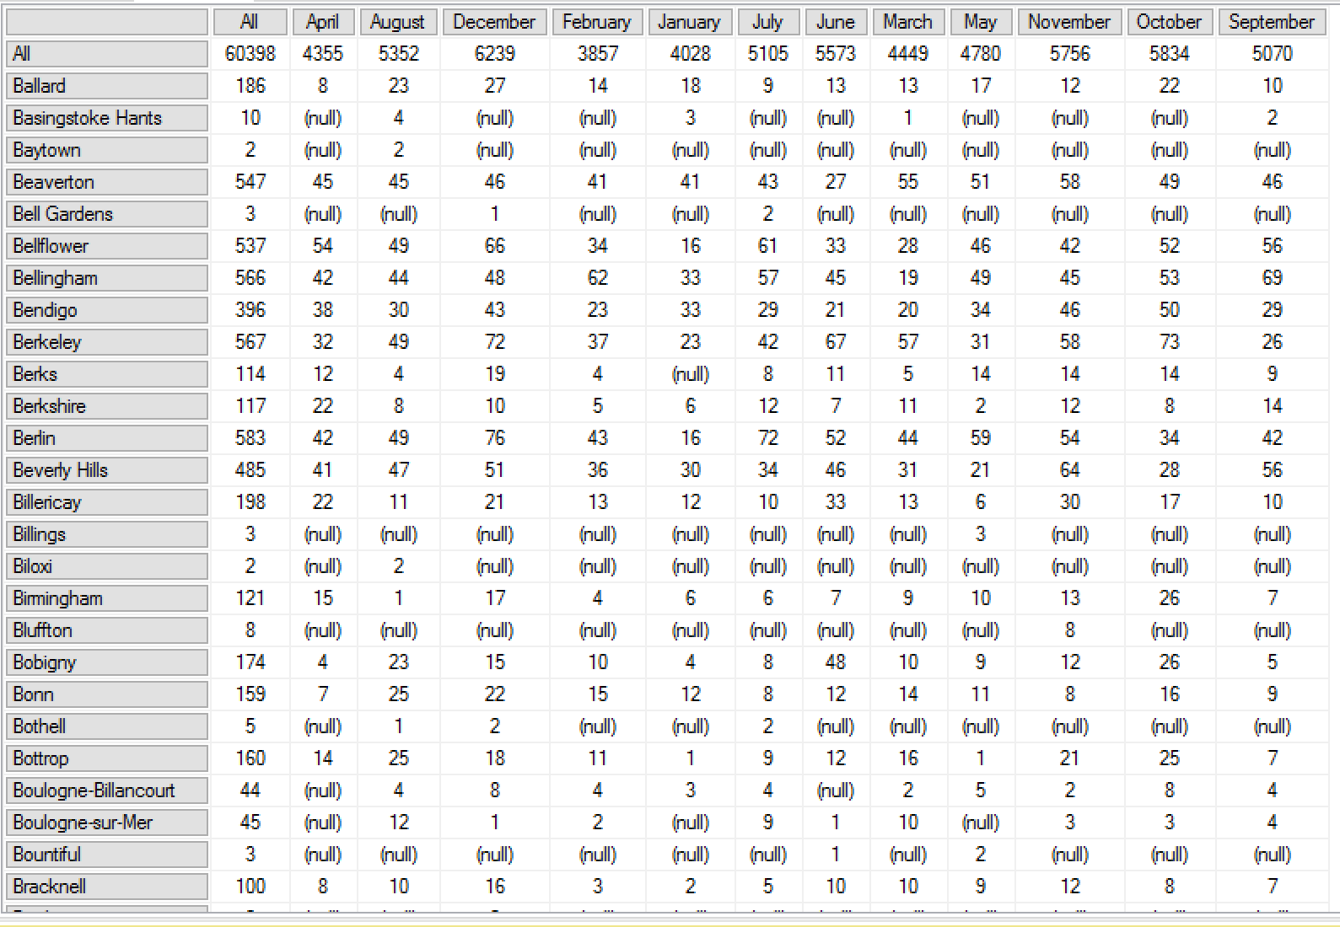

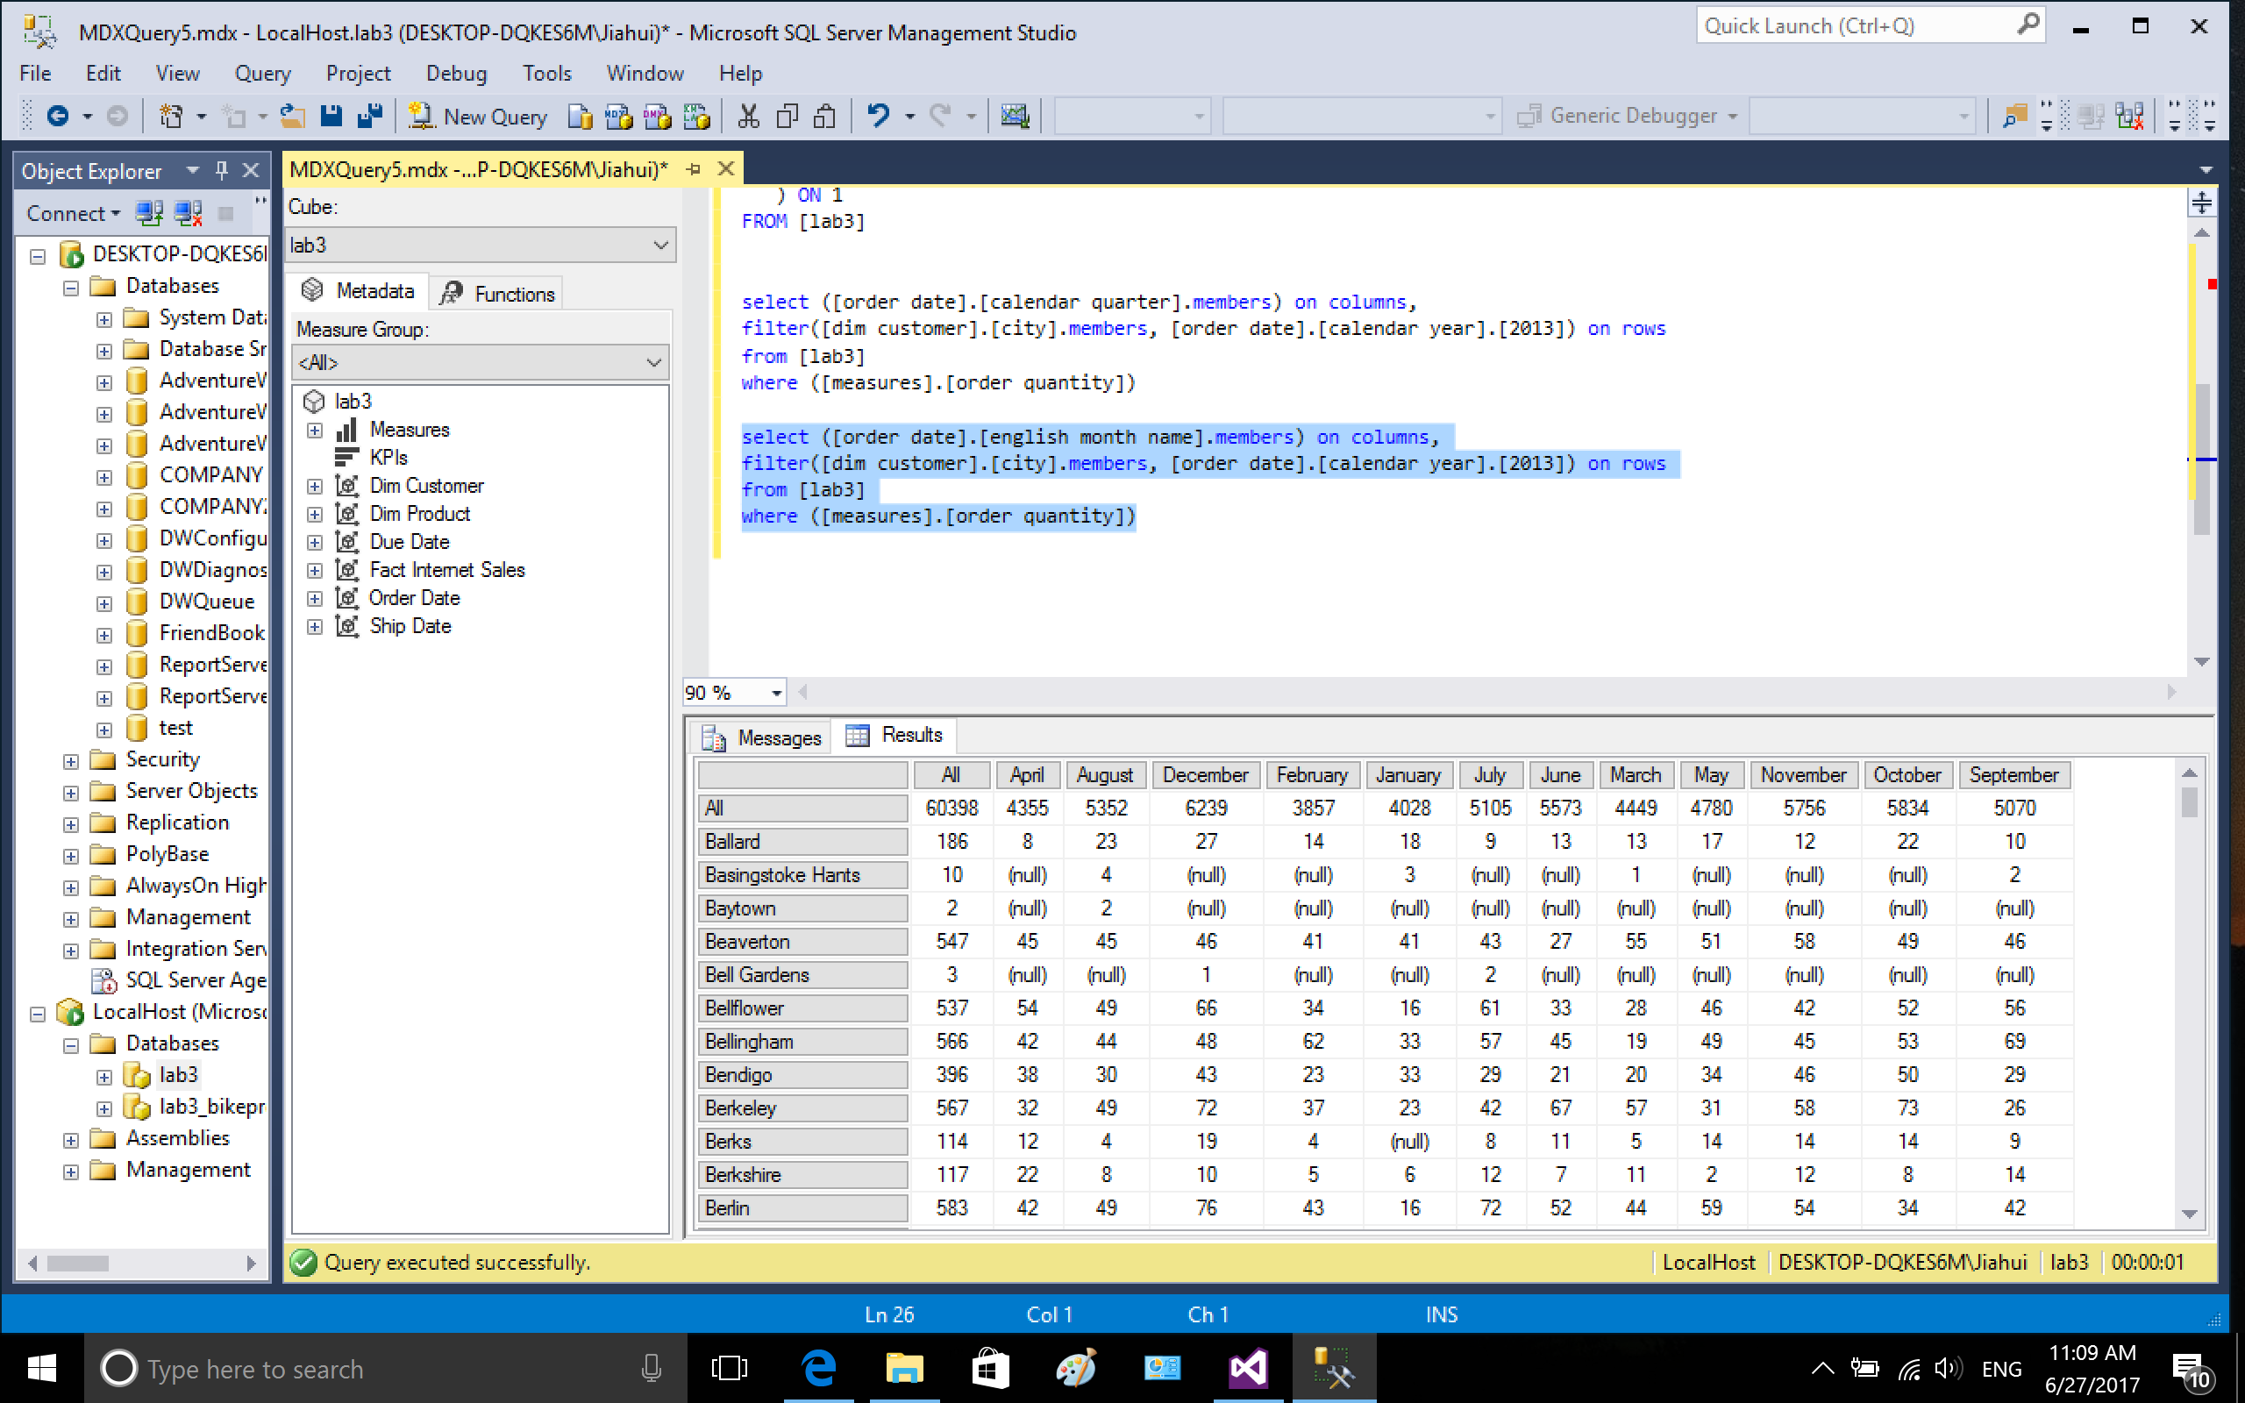

copy the result to excel and sort the ALL column.

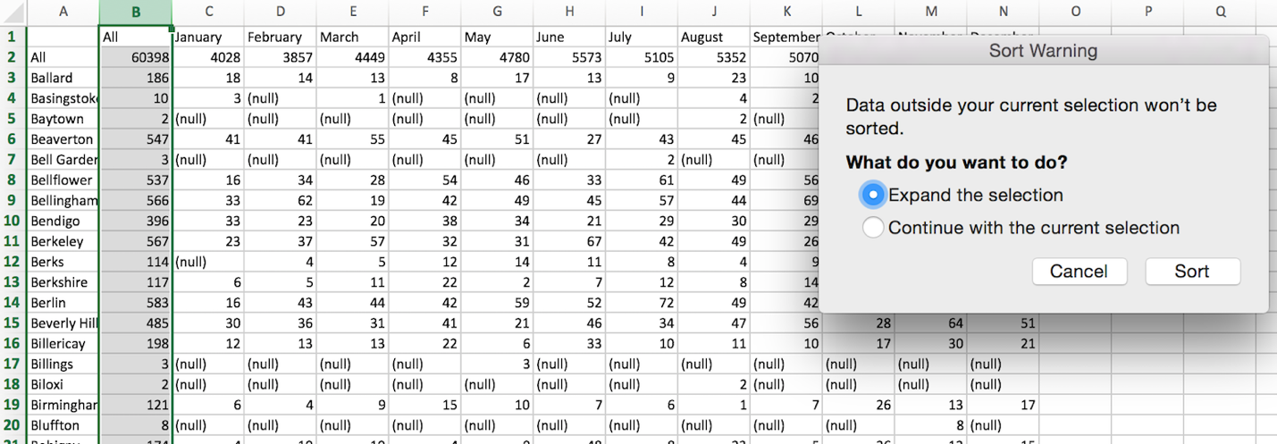

Select the cities with more than 500 bikes sold in year 2013.

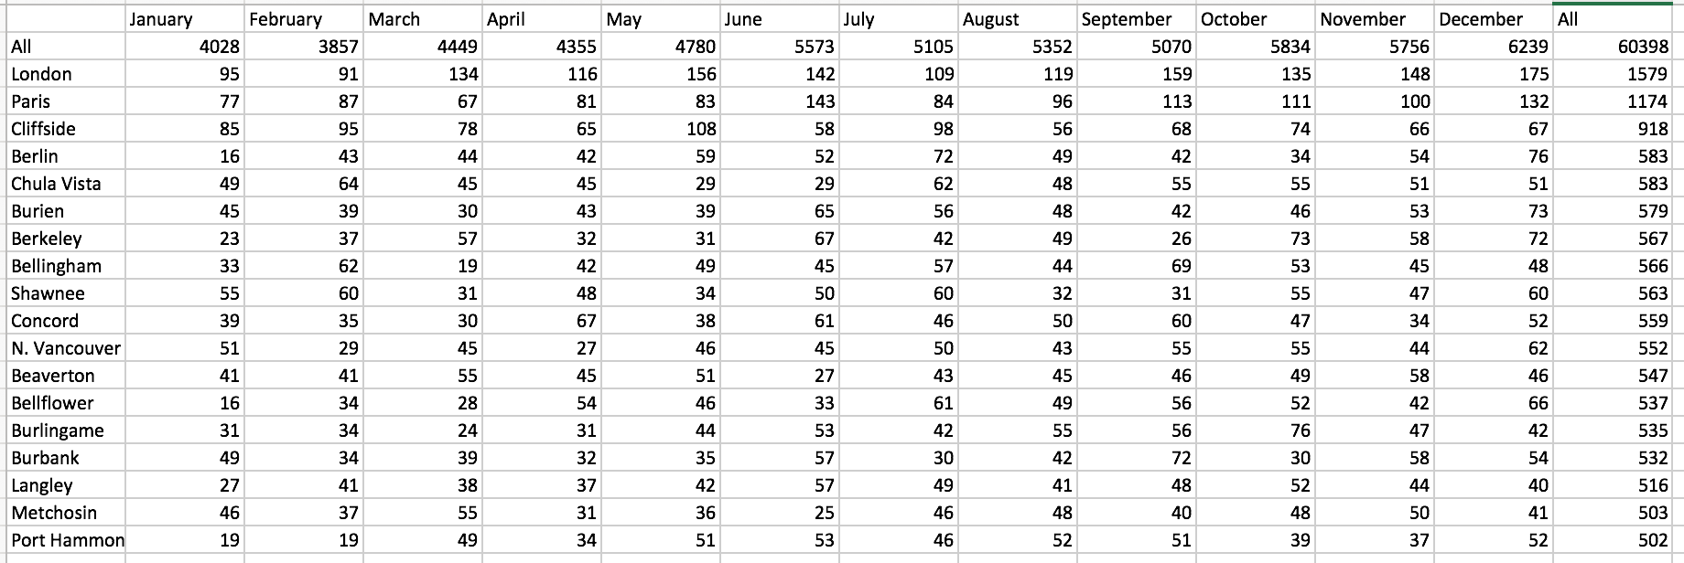

plot the scatter graph for All cities and individual cities.

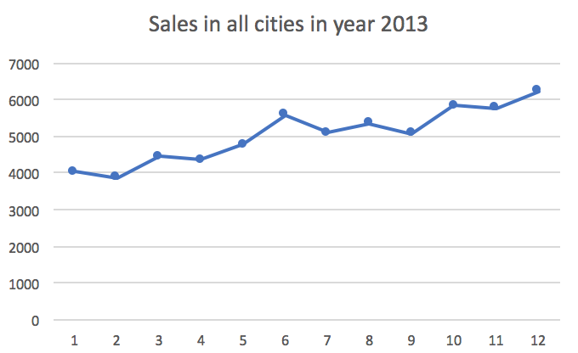

Monthly sales in cities (more than 500 bikes are sold) in year 2013

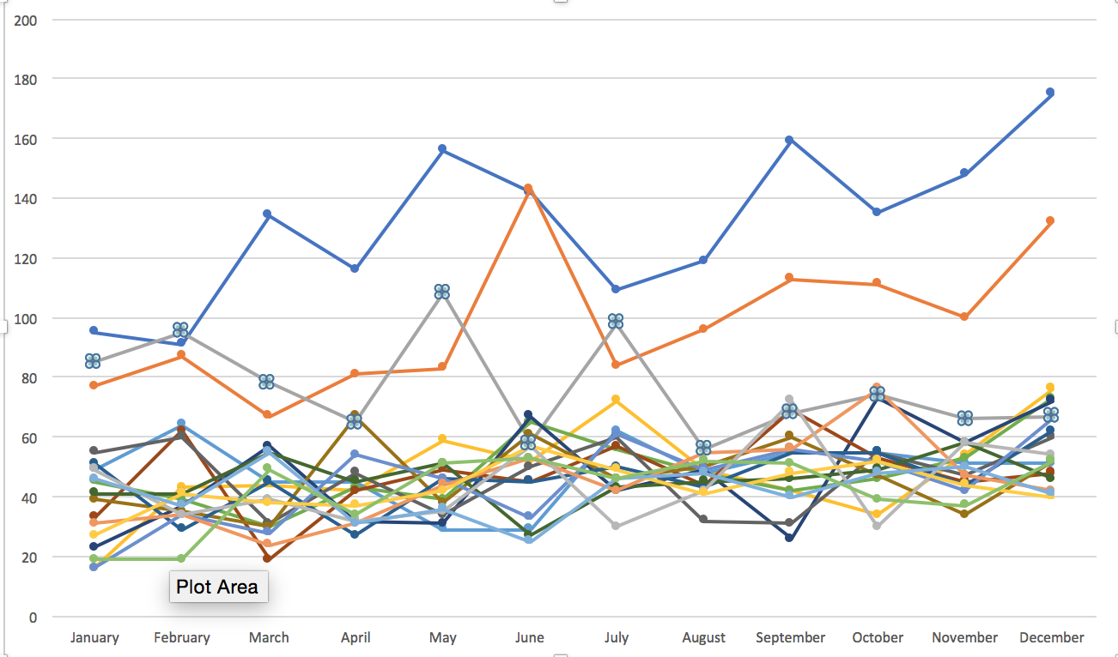

Using the same concept, the sale trend in cities such as Cliffside and Bellingham etc are unusual, because the holiday season sales October, November, December are less.

Part3 trouble shooting

I met some problems in doing lab 3, the following describes how I fix them.

3.1 retrieve data from SQL server

In the beginning, there is no connection between visual studio 2015 and SQL server, because the user is not a login in SQL server and has no read and write permission. I added user service\MSSQLserverOLAPService to SQL server login in securities, map and give the user read permission.

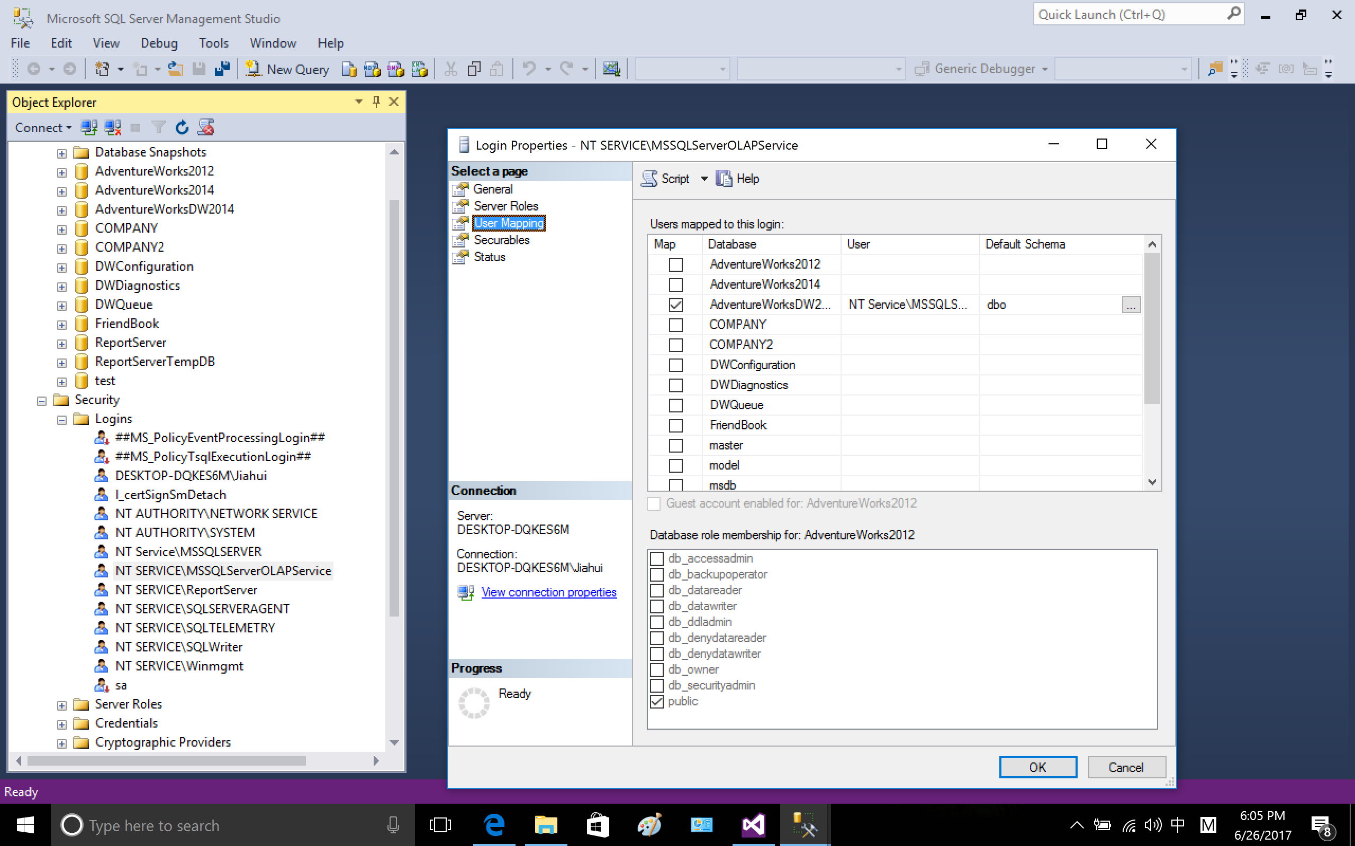

3.2 No data in year 2008, so I cannot use year 2008 to do prediction. Alternatively, there is very less data in year 2014, so I choose year 2013 to do the prediction.

The following shows the bike sales in all the years in different cities.

